Annual Report
2023-2024
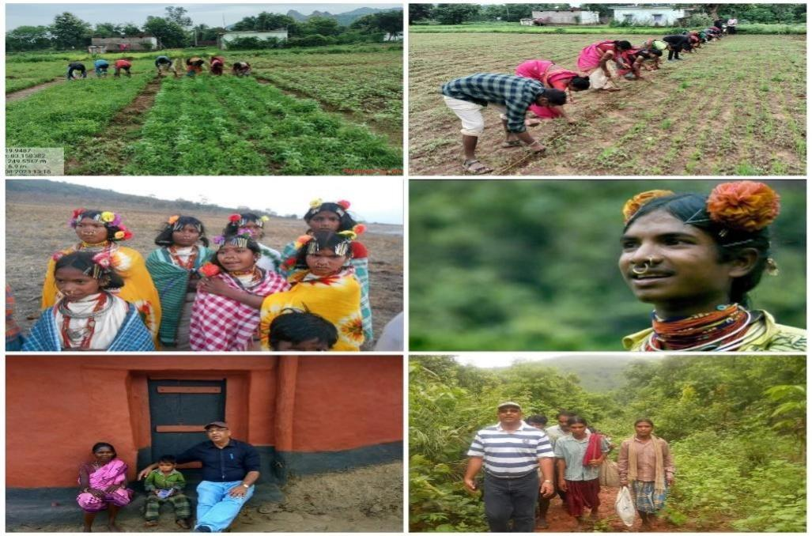

DAPTA
Development Agency for Poor & Tribal
Awakening,
Bhawanipatna, Kalahandi

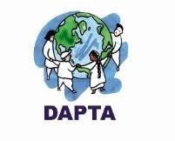

Contents

- Vision, Mission and Geographical Area
- Donor Wise Activities in 2023-24
- Thematic area of Intervention
- Executive Body Details
- Staff Details
- Training Facilities and Trainers Associated with
DAPTA
- Legal Entity
- Audited Statement -Attached Separate Sheet.

Secretary’s Desk……….

DAPTA’s strong commitment to uplift poor, tribal and women makes it a distinctive civil society organization. Being associated with DAPTA from its inception gives me immense pleasure, especially when I see the poor, tribal and women becoming more aware of their rights and taking charge of their own development.

I am very glad to present the Annual report of 2023-2024 in which year the organization has completed its 34th eventful journey. DAPTA, a development support organization, has diversified its journey in sustainable development of down trodden people, marginal community with a special' focus to the development of women, children and tribal people of Kalahandi and other tribal areas of Odisha since its inception.

DAPTA is working on four numbers of issues like Women empowerment', Agriculture and livelihood, Health care, Education child right and Humanitarian supports. Witnessing ground reality ‘we are working with some other network partners. DAPTA usually work for the people with community participation, community involvement and community led evaluation process to lead a sustainable change. This Year DAPTA has covered a large number of women and children mostly in its all project'. I am proud to say that DAPTA has set new goals for the next five years under the Country Strategy-V as a commitment to achieving the Sustainable Development Goals. It aims to bring a positive impact in the lives of the marginalized (poor, tribes, women and transgender) by 2025. This will be achieved through support from key partners including corporates, government, donors and civil society organizations. I am confident that we will achieve this goal.

On behalf of DAPTA, I express my deep gratitude to all our donors like SLCW, Central social Welfare Board. State Social Welfare Board, NABARD, OSACS, TDH Germany, Fusion Microfinance Ltd, MCC, Smile Foundation, Agricultural Technology & Management Agency, Reliance Foundation, WCD Dept. Millet Mission, Health Dept. and other donor partners. Moreover, we are grateful to Dist. Administration, Block Administration of Kalahandi and other Dist., NGO partners, WASSAN, CACL, LASK, Credibility Alliance, Guide Star, India Donates, FMSF, individuals, journalists, friends and associates those have supported DAPTA to achieve its objective and to touch the mile stone which is yet to achieve, yet to run miles and miles.........

Aadarsh Sharma
Secretary DAPTA

Vision
DAPTA’s vision is to eradicate poverty from the earth and to provide equal opportunity to all people
DAPTA’ s vision is that marginalized poor in India can live without poverty and access to equal opportunities.
Mission
DAPTA’ s Mission is to work with marginalized poor to alleviate poverty by overcoming injustice and inequity that causes it and to lead a meaningful life with sustainable protected environment and bio - diversity.
Geographical Area Covered ➢ Kalahandi District:
Block - 13
Gram Panchayat (G. P) - 97
- Nabarangpur
District: Block - 1
Gram Panchayat (G. P) -1
- Deogarh District
Block – 1
- Nuapada District Block- 1
  - Women Empowerment
      - FCC (Family Counselling Centre)
      - Domestic violence and adolescent trafficking
  - Livelihood and Food Security
      - Special Program for Promotion of Millet in Tribal Area of Odisha
      - Women Farmers Producer Company, LEDP, Rural Mart
      - Strengthening women’s Vegetable Grower Cooperatives
      - Livelihood, Water and nutrition Promotion

  - Health for All
      - Community Health and Education Program for PVTG Community.
      - HIV/AIDS with Transgender Community (T.I. Project)
      - Community Mental Health Care (Follow-up)
      - Menstrual Hygiene Management
      - Old Age Care
    - Education & Child protection
      - Mission Education Project
      - CHILDLINE Service, Kalahandi
    - Humanitarian Support
      - Cloth Distribution to Needy People

DONOR WISE ACTIVITY IN 2023-24

Sl. No | DONOR | ACTIVITY | AREA OF PROGRAMME
1. | SLCW, Switzerland | Promoting Women  Organization to combat domestic violence & antitrafficking. | Kalahandi District
2. | Central Social Welfare Board, Govt. of India | Family Counseling Centre | Kalahandi District
3. | Reliance Foundation | Improving the self-Reliance and Resilience of Rural communities | Bhawanipatna, Lanjigarh, Th.Rampur in Kalahandi District.
4. | NABARD | LEDP  Rural Mart | Bhawanipatna Block of Kalahandi District and Tileibani Block of Deogarh District.
5. | Millet Mission and  Dept. of Agriculture, Govt. of Odisha | Intensive Millet Promotion Activities in Tribal Areas | Bhawanipatna Block of Kalahandi District Golamunda Block of Kalahandi District.
6. | TDH Germany | Strengthening food  sovereignty for indigenous communities through a community-based gender initiative and participatory food security model based on traditional knowledge. | 6 GP of Lanjigarh Block, Kalahandi.
7. | Odisha State AIDS Control Society, Govt. of Odisha | HIV/AIDS Prevention,  Control and Care Program with 300 Transgender | Lanjigarh, Bhawanipatna, Jayapatna & Junagarh Blocks of Kalahandi District
8. | Fusion Microfinance Ltd | Menstrual Hygiene Management (behavioral change towards usage of sanitary napkins and hygiene in targeted schools and villages | Bhawanipatna Block & Kesinga Block of Kalahandi District
9. | Smile Foundation of India. | Non-formal Education and Nutrition | 132 deprived Children in 4 no of learning Center of Lanjigarh Block.
10. | Mennonite Central  Committee | Ensuring food and livelihood security of indigenous and other marginalized Communities | Thakurmunda Block, Mayurbhanj District, Odisha
11. | Department of Animal Husbandry, Govt of Odisha. | Animal Helpline- 1962 | Bhawanipatna Block of Kalahandi District.
12. | Child Fund India | Protecting the rights of children by building resilience of 2000 vulnerable household in Odisha. | 44 villages in Dharamagarh, Kalahandi  District  & Borden, Nuapada District.
13. | Sight Savers | Computer Education to  Visually Challenge person. | Bhawanipatna Block, Kalahandi District.



CHILDFUND

Supported by

BMZ

Project Title: Protecting the rights of children by building resilience of 2000 vulnerable Household in Odisha.
Operational Area: 33 village under Dharmagarh Block of Kalahandi district and 11 village under Boden block of Nuapada district.

Project duration: 36 months 01/10/2022 to 30/09/2025
Project Objective: The resilience of 2000 vulnerable households in 88 villages in Odisha is strengthened and the rights of children are protected from the dangers of emergency migration.

Programme Abstract:

 | Sl.No /Objectiv  e | Key activities accomplished | Reach
 | Sl.No /Objectiv  e | Key activities accomplished | Fr eq ue nc  y | UOM  (Nos.) | Tot  al | Fe ma  le | Ma  le | V  ill  a g  e | G P | B lo c k
 | Objective  : I | 1000 marginal farmers are engaged into climate smart agriculture and formation of collectives for improved earnings
 | 1 | Training & support to the marginal farmers on climate smart agriculture technology and Integrated farming system. | 4 | Farmer | 30  0 | 23  0 | 70 | 7 | 4 | 2
 | 2 | Direct seed and manure support to household | 4 | Farmer | 30  0 | 21  0 | 90 | 4 | 4 | 2
 | 3 | Concept Seeding meetings for Formation & Strengthening of 04 FPOs in each block | 8 | Farmer | 30  9 | 14  0 | 16  0 | 8 | 4 | 2
 | Objective  : II | 1000 youths are trained market-appropriate skills and engaged in gainful employment or are self-employed
 | 4 | Vocational and skill building training of youth through Odisha Skill Development Mission. | 1 | Youth | 19  4 | 95 | 99 | 1  1 | 4 | 1
 | 5 | Training and supported with backyard poultry units. | 10 | Youth | 50 | 12 | 38 | 2 | 1 | 1
 | 6 | Training and supported with Goatery units | 1 | Youth | 40 | 17 | 23 | 9 | 2 | 1
 | 7 | backyard poultry support (animals + food + medicine + equipment) | 7 | Youth | 17  5 | 98 | 77 | 2  1 | 2 | 2
 | Objective  : III | All children in the targeted community are enrolled and retain in school and continue school education
 | 8 | Books and Study Material support | 1 | Children | 84 | 43 | 41 | 4  2 | 1  1 | 2
 | 9 | Running of child learning centers | 1 | CLC | 20 | — | — | 2  0 | 1  1 | 2
 | 10 | Students studying in child learning centers | — | Students | 57  6 | 32  4 | 25  2 | 2  0 | 1  1 | 2

 | 11 | Teachers trained on effective teaching learning methodology. | 1 | Teachers | 20 | 10 | 10 | 2  0 | 1  1 | 2
 | 12 | Strengthening Community Involvement and  Participation in schools. | 3 | Stakehold er-  Participant | 90 | 52 | 38 | 3  0 | 8 | 2
 | Objective : IV | Fully functional Community Vigilant group to prevent children from trafficking and all child rights are protected
 | 13 | Establishment of Help Desk | 1 | Help Desk | 4 | — | — | 4  4 | 1  1 | 2
 | 14 | Formation and strengthening of VLCPC in 88 villages and PLCPC in 26 Gram Panchayats | 18 | Members-  Participant  s | 35  2 | 13  8 | 21  4 | 1  8 | 4 | 2
 | 15 | Capacity Building of different stakeholders at GP and Block. | 1 | Stakehold er-  Participant | 30 | 14 | 16 | 8 | 1 | 1
 | 16 | Networking and liasoning meeting with different stakeholders. | 1 | Stakehold er-  Participant | 40 | 16 | 24 | 3  3 | 7 | 1
 | 17 | Mapping of CBCPM and establish linkages with Government schemes and services | 14 | Stakehold er-  Participant | 28  0 | 10  5 | 17  5 | 1  4 | 4 | 1
Output wise progress during the year
Output – 1: 1000 marginal farmers are engaged into climate smart agriculture and formation of collectives for improved earnings

- Direct seed and manure support to households along with fencing net
In Dharmagarh & Boden blocks, 140 farmers initiated the process of field preparation with high quality heat resistance seed variety, and organic manure. Apart from the seeds and organic manure, the farmers were also provided handholding support to select crops for mixed cropping, maintain space while sowing, irrigate at regular intervals, practice mulching, and prepare organic insecticides and pesticides. All most all farmers have harvested different types of vegetables for their consumption and for sale.

- Formation & strengthening of Farmers Producers Organisations
During the period, 8 concept seeding meetings were conducted with 309 farmers (184 male farmers and 124 female farmers) with an aim to establish farmers’ producers’ companies (FPCs). The meetings addressed the agenda on collectiveness, importance of producer companies, their modalities as well as the legal aspects.

Output – 2: 1000 youths are trained market-appropriate skills and engaged in gainful employment or are self-employed
- Vocational and skill building training for youth
In collaboration with the Odisha Skill Development Mission and Odisha Rural Development & Marketing Society, Employment Exchange Officer & DAPTA organised Vocational and skill building training camp at Boden and provided career guidance to 98 youths and enabled them to take informed decisions and choose their career paths wisely for better future.

- Support to youths for Income Generation Activities
175 youths were trained on poultry and goat rearing. The capacitated youths were supported with total
3,500 high quality desi breed chicks, feeds, medicines, farm equipment such as drinker, feeder etc.
Regular follow up is being undertaken by the team and a veterinary doctor to ensure minimum or zero mortality of the chickens provided.

Output – 3: All children in the targeted community are enrolled and retain in school and continue school education
• Teachers trained on effective teaching learning methodology.
A three-day training was also organized to capacitate the facilitators on a child friendly pedagogy which included teaching through stories, poems, and play materials. The training sessions also capacitated them to prepare a teaching learning material to ensure a child learns age-appropriate numeracy, literacy and social emotional skills. Regular parents’ meetings were conducted in each village to encourage the parents to regularise their children to learning centres and formal schools.
- Books and Study Material support
Study materials distributed to 84 needy and to be dropout students of 42 villages of Dharamgarh and Boden block. Students along with their parents were sensitized about the importance of value of education and motivated them through known popular opinion local persons of the area. A small and short meeting was organised at School level to involve the teachers in this process.
- Running of Child Learning Centres
With an aim to support the children in attaining age-appropriate learning, a total of 20 Child Learning Centres (CLC) were established in 20 villages. In this quarter, these CLCs provided educational support to 576 children. The centres were also successful in identifying 26 slow learning and 89 drop out children. The counselling sessions provided to the parents of such children were instrumental in bringing them back to their schools.

- Strengthening Community Involvement and Participation in schools.
Three capacity building of SMC members were organised, several key points & challenges were mapped and addressed. focus was given to enhance standard of school education system, conducive learning environment, reduce the number of dropouts and better protect children's right to education and to support & develop a participatory school development plan and regularly monitor its implementation effectively.

Output – 4: Fully functional Community Vigilant group to prevent children from trafficking and all child rights are protected
- Formation and strengthening of Village Level Child Protection Committees (VLCPC) at Village and GP Level
During this year period a total of 18 VLCPCs were formed with 352 VLCPC members. These VLCPCs were also successful in identifying 43 child protection issues, and could also liaise 18 children at risk with government schemes such as Ashirwad Scheme to support the families financially. Apart from this, seven cases of child marriage were also resolved.

- Capacity Building of different stakeholders at GP level
Trainings was conducted covering a total 30 participants. The participants included Members of child protection committee, PRI representatives, and community leaders. In the training the participants were oriented on Project Vatsalya, role of community to ensure child protection, reporting mechanism to address the Child protection issues etc.
- Networking and liasoning meeting with different stakeholders.
Linkages and network with various govt. line departments were developed such as Integrated Child Development Services (ICDS), Block Education Officer, IIC, Primary Health Dept., Mission Shakti, National Rural Livelihoods Mission (NRLM), of Agriculture, of Forest and Environment of Water

Resources, Soil and Water Conservation Departments; Department of Horticulture, and PRI members participated in the networking meeting.

• Mapping of CBCPM and establish linkages with Government schemes and services
Mapping of Community based Child Protection Mechanism was conducted in 14 villages in Kankri, Tipiguda, Dumerguda and Tendapali of Dharamgarh block. Various existing Child Protection issues and gaps were identified for addressing and contribute to create community-based plan and follow up with VLCPC, elected representatives, local networks and service providers.
Raised parents’ awareness of children's rights, such as providing adequate care and services, linking with government programmes and strengthening school management committees, government officials for immediate redressal/tracking of child protection cases.
• Establishment of Help Desk
Two help desks were set up during the reporting period in four target blocks.
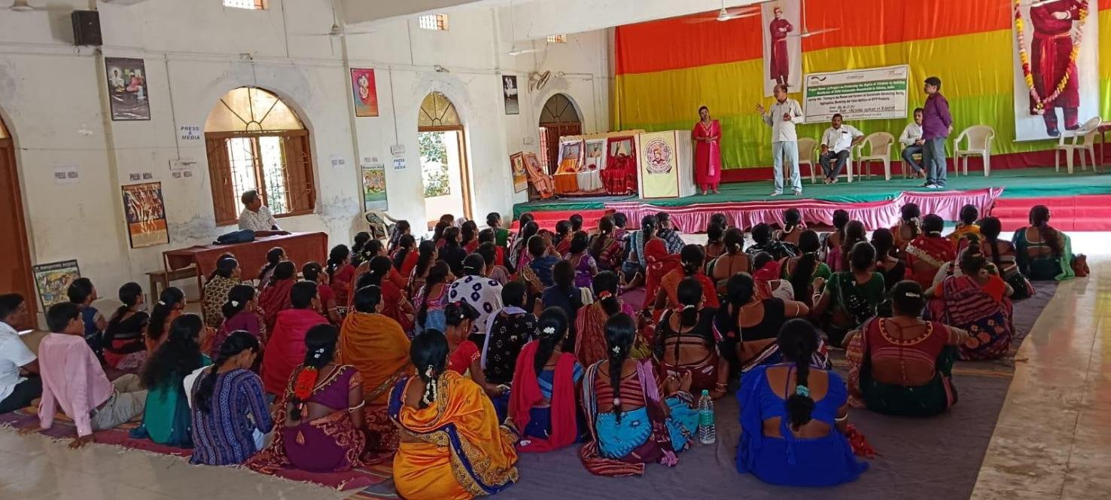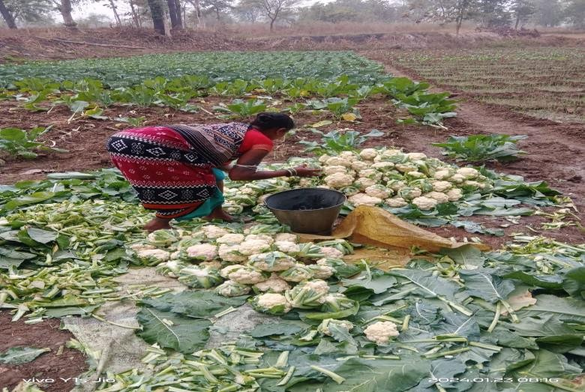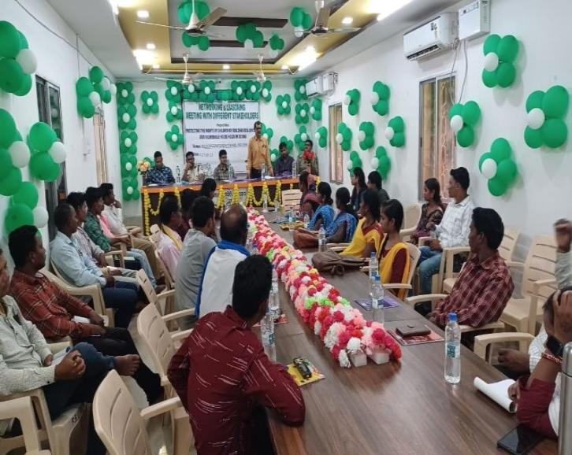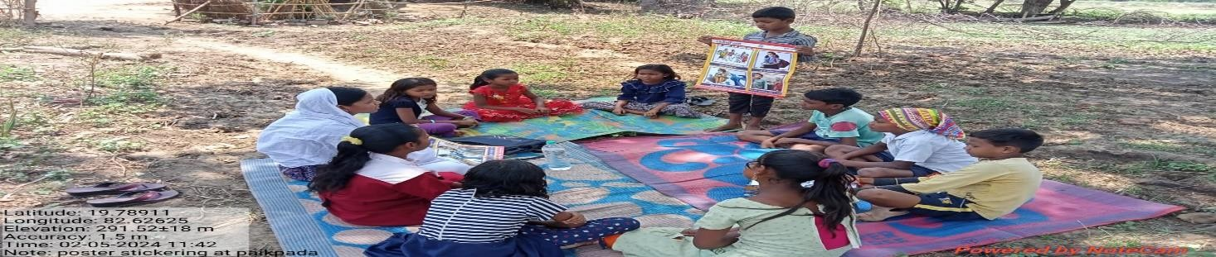

Targeted Intervention Project (T.I, Project)

Supported by Odisha State Aids Control Society (OSACS)

DAPTA, with the support from Odisha State AIDS Control Society (OSACS) has implemented the targeted intervention project in Bhawanipatna, Lanjigarh, Junagarh and Jayapatna Block of Kalahandi district. In the year 2023-24, DAPTA have covered 374 beneficiaries, out of them 245 are MSM & 210 are TG.
➢ Project Objective:-
- Prevention infections through saturation of coverage of high-risk group with Targeted Intervention scaled up intervention in a general population.
- Provide greater Care, Support & Treatment to larger number of PLHAs (60%).
- Strengthen the infrastructure system 7 human resources in Prevention, Care & Support programmes at District, state and National level.
- Increasing awareness and knowledge about HIV/AIDS, ways of transmission, and ways of preventing transmission among the selected groups.
- Increasing knowledge about CONDOM and its use by the target groups. Increase knowledge about the signs and symptoms of STIs and increase appropriate treatment seeking for STIs.
- Make the environment more conducive for carrying out HIV/AIDS related awareness and promotional activities, through appropriate advocacy.

Sl.  No. | Activity | Target | Achiev ement | Percentage
1 | One to One Contact | 5160 | 4999 | 96%
2 | Regular Contact | 4920 | 4823 | 98%
3 | Condom Demand VS. Distribution | 30300 | 28813 | 95%
4 | No. of HRGs counseled | 2120 | 1817 | 85%
5 | No. of HRGs refer to ICTC | 910 | 890 | 97%
6 | No. of HRGs tested at ICTC | 900 | 883 | 98%
7 | No. of HRGs tested at Network Clinic | 1720 | 1620 | 94%
8 | Regular Medical Check up | 1573 | 1473 | 93%
9 | STI ` | NA | 67
10 | Presumptive Treatment | 94 | 80 | 85%
11 | No. of HRGs tested at RNTCP | NA | 118

Activities | Outputs
Demand Generation Activity | We have organized 60 no. of Demand generation meeting at our different hotspot. The objective behind the activity is to increase HIV/TB testing, protective sex. We also discussed on signs and symptoms of HIV/AIDS, STI/STD, uses and benefit of ART medicine & safe behavioral practices. During the year we covered 420 key populations through the hotspot meetings. 80 no of new HRG (key population) identified during the meetings.
Health Camp | We conducted 2 nos. of Health camp at Bhawanipatna and Jayapatna operational area. In this camp we covered 95 nos. of HRGs and checked up their health status by a Doctor and provide medicine as per their disease. We also organized a small awareness meeting on their personal hygiene, healthy life and advice them on HIV/AIDS, STD/STI and safe sex.
World AIDS Day | On the eve of World AIDS day we the DAPTA TI observed World AIDS Day week from 25/11/2023 to 1/12/2023 at the different hotspot of our operational area with our HRGs. During these days we spread the awareness end the stigma near of the HRGs and others. Through various events, small group meetings and one to one contacts our PE, ORWs were trying to aware the people on HIV/AIDS & spread the message of global solidarity shared responsibility.
Advocacy Meeting | This year we conducted 4 nos. of Advocacy Meeting with different service providers of our project area. Objective of this meeting was to initiate the HIV testing of Key Population, linkage them to social scheme and give social justice in their day today life. It was decided to have proper coordination and mutual understanding with all service providers.
Community Event | On 22 to 25th February 2024 TI Project DAPTA organized a Community event for creating awareness among the Key population at Jaipatna Site. In this occasion we organized a small group meeting where we gave brief knowledge on various topics.  - Why TI project is working for MSM/TG community.  - Component of TI.  - About HIV/AIDS  - About PLHIV & their treatment  - Condom Promotion  - Social security scheme

PHOTO GALLERY
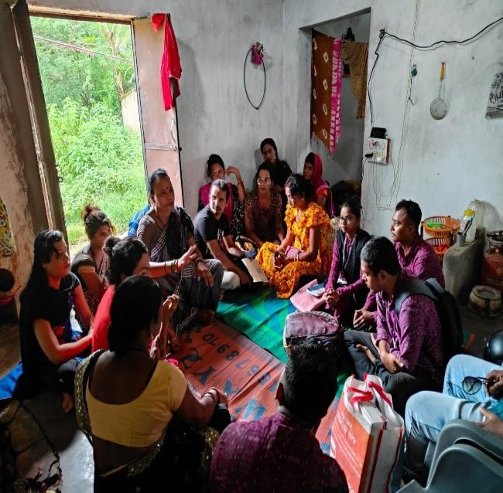  Demand Generation Meeting | 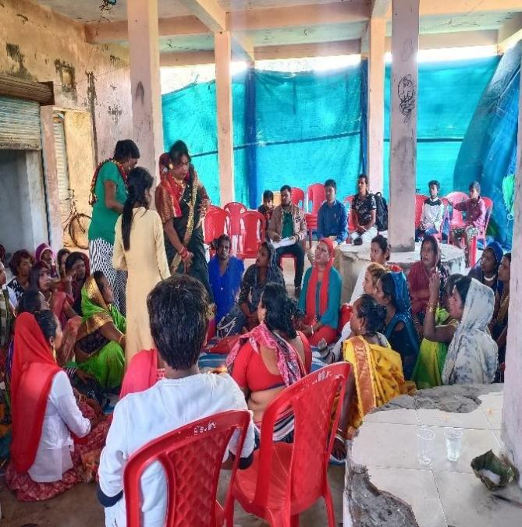  Celebration of World AIDS day
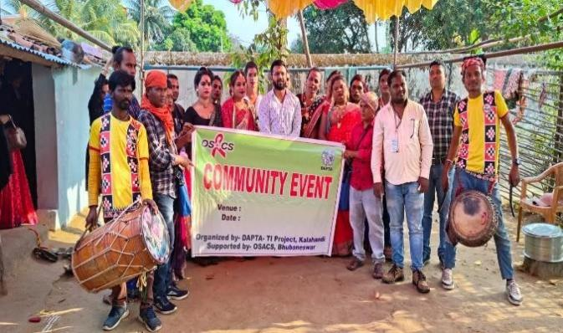  Community Event | 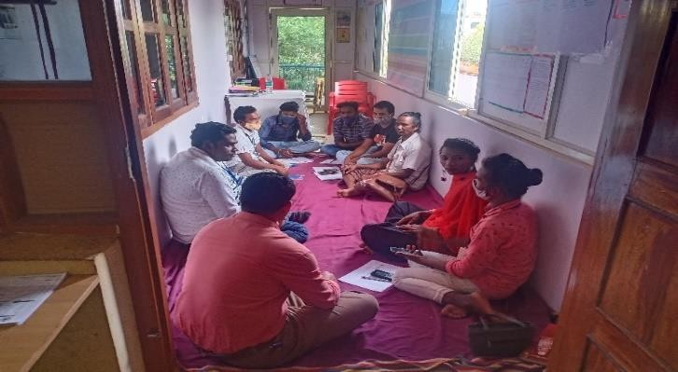  Staff Review Meeting  Staff Review Meeting
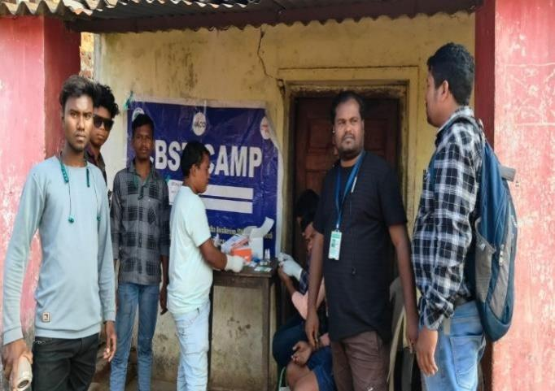  Health Camp  Health Camp | 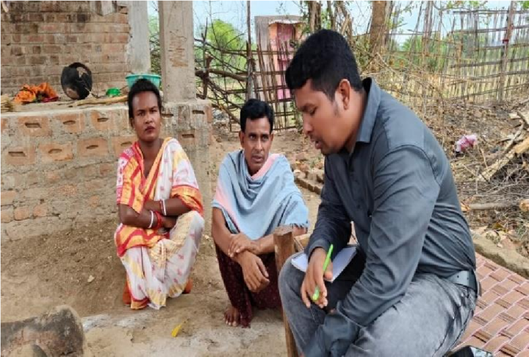  Field Visit

Animal Helpline- 1962 Supported by Department of Animal Husbandry, Govt of Odisha

About AHL:
AHL work for rescuing injured or abandoned animal, providing medical care, rehoming, and offering advice and resources to pet owners. AHLs often operate hotlines or online platforms where people can report animal emergencies or seek guidance on animal-related issues. These helplines play a crucial role in animal welfare and advocacy.

Objective-
- Improving lives of stray, abandoned and distressed animal

Objective specific-
- To provide veterinary health care services to stray and abandoned animal on receipt of the calls from the state animal helpline call centre.

Activities:
- Responding emergency calls and offer needed treatment of injured and distressed animal.
- Free ambulance service to the distressed animal as soon as possible upon receiving a call/communication.
- Shifting of sick/injured animal to the nearest appropriate facility for the necessary treatment and care.
- Proper disposal of animals recovered from the accident sites within Bhawanipatna Municipality jurisdiction with due consultation to the appropriate authority.
- Active support & coordination in the implementation of ABC programme adhering to prescribed guideline.
- Active facilitation and support in the early neutering of dogs.
- Awareness and education to build a human-animal co-existence conducive environment to achieve and sustain the desired objective.
- Spreading and propagating the existing animal laws and key messages to enhance awareness and sensitization.
- Helping the authority in gearing up the targeted animal population control initiative.
- Establishing rapport with the targeted community for the effective implementation of AHL services.
- Establish coordination and network with the like-minded organization, stake holders and individuals to ensure an enabling environment for the animal care and service.
- Maintain and update a database, impact report and document the practices and success stories on AHL programme.

Achievement:
No of case animal | 643
No of animal treated | 567

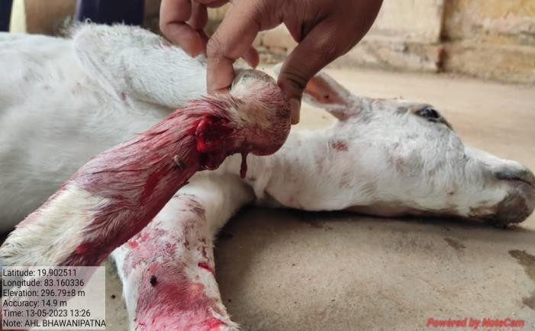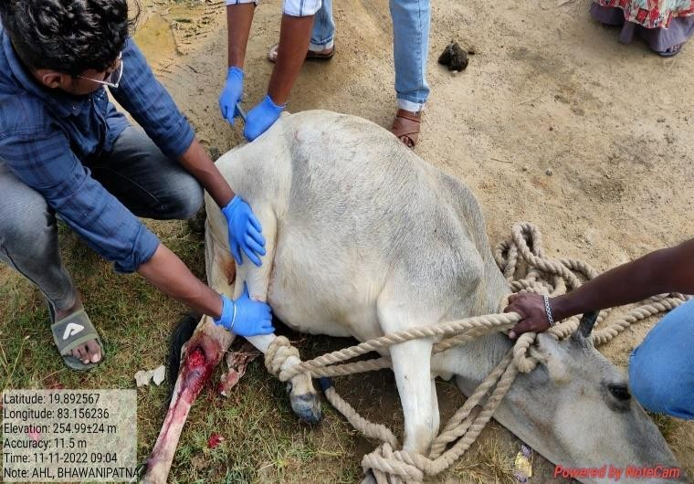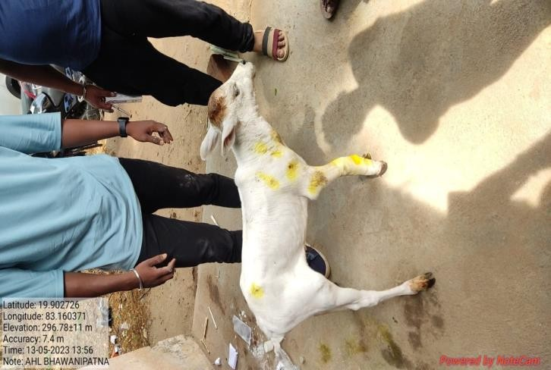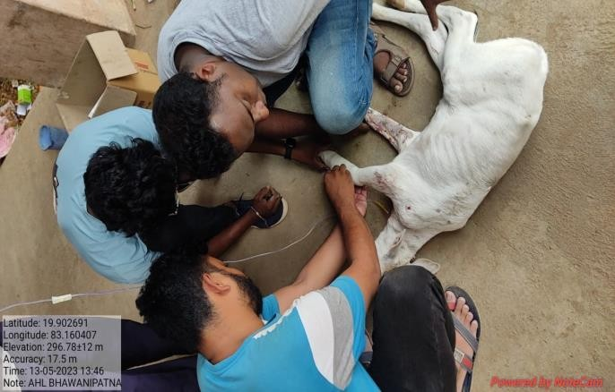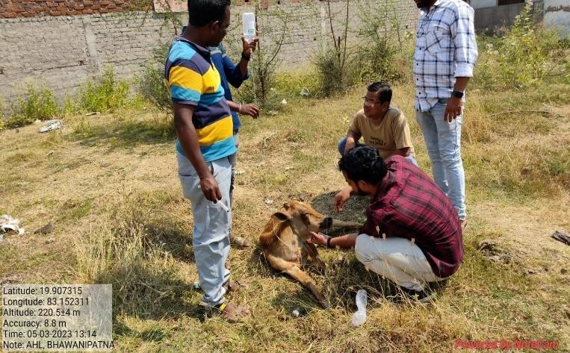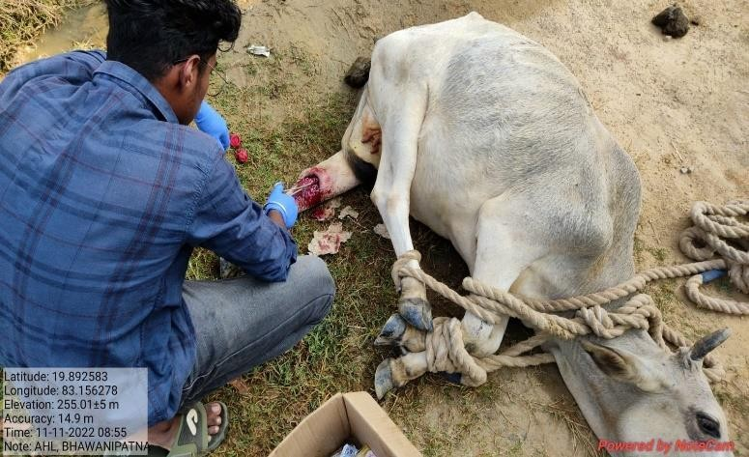
Progress in pictures
:

Menstrual Hygiene Management (GARIMA)

Supported By: Fusion microfinance Limited

The Program “Garima” started in the Month of December 2022, supported by Fusion Microfinance
Limited and implemented by DAPTA, Kalahandi. Initially, two blocks were selected for the project i.e. Bhawanipatna and Kesinga where 12 villages come under the Bhawanipatna block and 4 are from Kesinga Block. Under Bhawanipatna block villages are-Laxmipur, bijepur, Sradhapur, Bhejipadar, Borbhata, Sankhairmal, Bhawanipur, Udepur, Dakabahali Dorapadar, Karlasodha, Ghusrigudi, and under Kesinga block Villages are- Kundabandha, Boria, Jolko, Laitara.

ACHIEVEMENTS:
Total Villages | 16
Total target for sanitary napkin distribution in session 1 | 6000
Total achieved | 5266
Total target for sanitary napkin distribution in session 2 | 6000
Total achieved | 5951
Total target for sanitary napkin distribution in session 3 | 6000
Total achieved | 6000
Total target for sanitary napkin distribution in session 4 | 6000
Total achieved | 5904
Grand Total (1st+2nd+3rd+4th sessions) | 23,121

FINDINGS:-
• Total women and girls’ details (age wise): -
Session | 11-17 | 18-28 | 29-45 | 50&above
1st session | 1204 | 1900 | 2123 | 39
2nd session | 1917 | 1762 | 2231 | 41
3rd Session | 1851 | 1737 | 2351 | 61
4th Session | 1716 | 1756 | 2251 | 82
Based on the session report, out of a total of 6000 beneficiaries, an overwhelming majority, specifically 98.6% (5724 individuals), are utilizing the sanitary napkins provided by Fusion. A small percentage, accounting for 1% (56 individuals), continue to use cloth for menstrual hygiene, and a further 0.4% (24 individuals) have opted for pads purchased from the local market. These statistics highlight the significant success of the Fusion program in promoting the adoption of sanitary napkins among the targeted beneficiaries.

KEY ACTIVITIES TAKEN ON ALL SESSIONS:-
Monthly plan | Brief description of activities & achievements
In 1st, 2nd, 3rd & 4th session | - In 16 villages 6000 women and girls covered through MHM session.  - Meetings and awareness session has been conducted with adolescent girls and women, below topics are discussed in the session-  - All the participants are aware about different types of sanitary napkin its uses during periods  - Importance of menstrual hygiene for overall health and well-being.  - Understanding the menstrual cycle and its different phases.  - We have Demonstrations Matka Incinerator for disposal of sanitary napkins.  - Correct usage and placement of sanitary napkins.  - Changing frequency to maintain hygiene and prevent infections.  - Exploring various menstrual products such as tampons, menstrual cups, and reusable pads.  - Discussing the pros and cons of each option. Strategies for raising awareness about menstrual hygiene in rural communities.  - Open discussions on cultural taboos and stigmas surrounding menstruation.  - Encouraging girls to share their experiences and challenges.  - Empowering girls to challenge and change societal attitudes.  - Discussion on healthy dietary habits to support menstrual health.  - Distribution of pads  - Registration of beneficiaries of 1st, 2nd,3^{rd &} 4th session

8 DAYS PAD STITCHING & SELLING TRAINING:-

INTRODUCTION
Fusion Microfinance, along with DAPTA Organization organized a 8 days training on sustainable menstruation for the Community level change makers at Uditnarayanpur Village which is under Kamthana Gram Panchayet, Bhawanipatna Block, Kalahandi district Odisha. 25 women have got the training on sustainable menstruation (sustainable reusable cloth pad making) &Network Establishment. First day of the training Mr Aadarsh Sharma (Secretary, DAPTA) welcome to all the Participants and facilitator, he explained about the objectives of the training. The trainer introduced herself and told about her respective work in the field of menstrual health and hygiene. Anahat For Change Foundation's Deblina Sarkar was appointed as a trainer for the entire program.
Purpose of the Training
To create an awareness on sustainable menstruation, handhold support to make their own reusable cloth pad also provided them the knowledge of branding, marketing & selling of the reusable cloth pads to their nearby community.
Topics covered in 8 days Training-
- Ice breaking & introduction to ethics & values
- Definition of Adolescent
- Changes during adolescent period
- Pre-menstrual syndrome
- Sustainable Menstruation
- Cloth pad making step by step process
- Capacity building training on Marketing, branding & pricing

CONCLUSION
In conclusion, the comprehensive insights derived from the session reports shed light on the transformative impact of the fusion program on menstrual hygiene practices among the targeted beneficiaries. The overwhelming adoption of sanitary napkins, with 98.6% of women utilizing Fusion pads, underscores the success of the initiative. The transition from cloth to pads was driven by awareness initiative, improved comfort, and newfound knowledge about safe usage.

However, challenges persist, including the need for better accessibility to sanitary pads, as highlighted by 86.1% of respondents expressing inadequate in a single packet for their menstrual needs. The disposal practices also varied significantly, emphasizing the importance of addressing waste management and promoting hygiene methods.

The feedback on Fusion pads was generally positive, with 44.1% expressing satisfaction, while economic constraints and personal preferences influenced others. Insights into the usage of matka incinerators revealed practical challenges, emphasizing the importance the importance of considering user experiences in promoting sustainable menstrual hygiene practices.

Despite the challenges, the project benefited for strong support and effective coordination with ASHA and AWWs, as well as positive collaboration with village leaders. Initiatives such as adjusting outreach schedule to align with the community’s daily routines demonstrated adaptability and resilience.

In moving forward, addressing affordability concerns, improving product quality, and aligning with culture preferences are crucial consideration. Additionally, targeted awareness campaigns on waste management and sustained collaboration with community leaders can further enhance the success of such initiatives. Overall, the fusion program lays a foundation for continued efforts to promote menstrual hygiene, recognizing the importance of adaptability, community engagement, and a holistic approach to address the multifaceted challenge faced by women in the target communities.

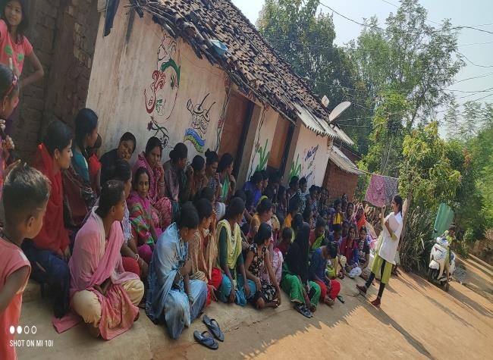
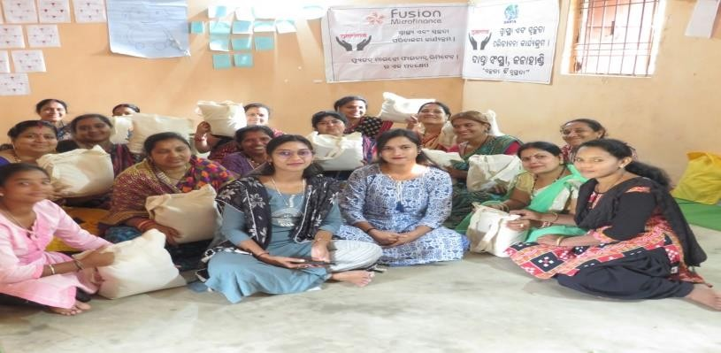
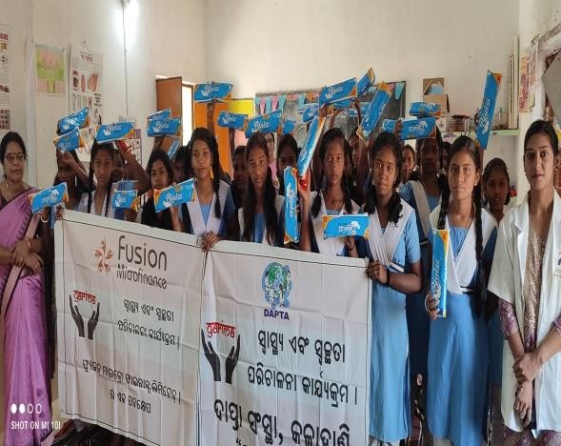
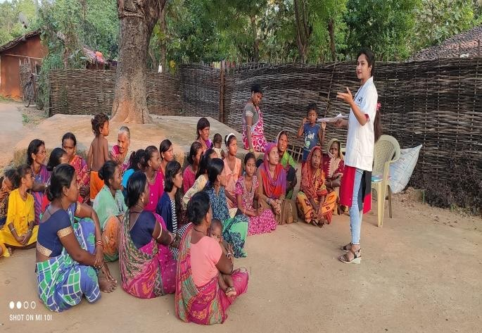
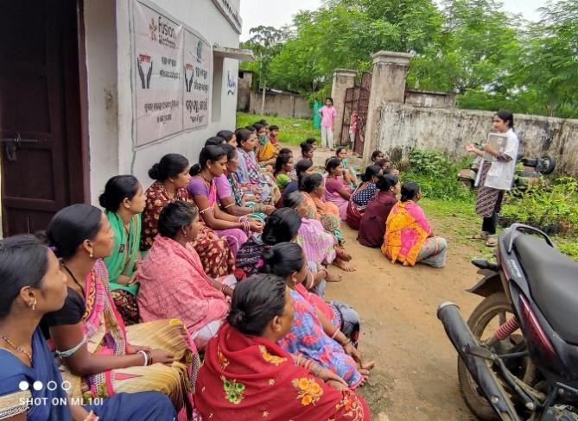
Photo Gallery:-

Name of the project: -Special Programme for Promotion of
Millets in Tribal Areas of Odisha BLOCK-BHAWANIPATNA & GOLAMUNDA

Supported by Millet Mission Govt. of Odisha

Project Background:
Odisha Millets Mission a flagship programme of the Government of Odisha, Special Programme for Promotion of Millets in Tribal Areas of Odisha (Odisha Millets Mission) was launched by Govt of Odisha in 2017 to revive millets in farms and on plates.To promote millets in its tribal areasis being implemented in Kalahandi district since Kharif 2017. It emerged from a consultation between Government, Academia (NCDS) and Civil Society Organisations (RRA Network, ASHA Network and local NGOs). It is first of its kind of agriculture programme with priority on increasing consumptions in Odisha.

The program has evolved after state level consultations on the subject and mitigate drought in Southern Odisha held on January 2016 by Planning and Convergence Department, Government of Odisha of NCDS, Bhubaneswar and multiple stakeholders. We ware started the programme on 1st January-2018 from DAPTA; Bhawanipatna has one of Facilitating Agency and FPO- Dukuri Women Farmers Producer Company Ltd.

This comprehensive project includes campaigns for revivals of millets in household consumption, improving productivity of millet crop systems, promoting local processing enterprises and developing markets.

Project Objective: -
- Increasing household consumption of millets by about 25% to enhance. household nutrition security and to create demand for millets with focus on women and children.
- Promoting millet processing enterprises at Gram Panchayats and Block level to ease processing at households and for value added markets.
- Improving productivity of millets crop systems and make them profitable.
- Development millet enterprises and establishing market linkages to rural / urban markets with focus on women entrepreneurs.
- Inclusion of millet in State nutrition programs and public distribution system.
- To promote organic farming on Millets.
- To get more net profit.
- To prevent labour migration.
- To utilize family labour properly.
- To utilize highlands and unutilized lands.
- To improve livelihoods of the farmers.
- To skill development of farmers on nutrient value of Millets.

INFORMATION OF ACHIEVEMENT-2023-24 UNDER ODISHA MILLET
MISSION, BHAWANIPATNA & GOLAMUNDA BLOCK, DISTRICT-
KALAHANDI

Area of operation/Geographical area:

We worked in 183 nos. of villages of 26 GPs in Bhawanipatna block of Kalahandi district in 20232024.

Number of Beneficiaries reached out-
In finance year 2023-2024 reached out 1543 nos. of millet farmers.
Details mentioned below-
Year | Area Achievement (in hector.) |  | Total Millet Farmers | Incentive paid to farmers from Govt.  (in Rs.)
2023-24 | Kharif | 743.56 | 1543 | 4963450/-
N:B. | Total 4737 quintal of Ragi procurement from Millet farmers in Bhawanipatna block (KMS-2023-24).

Target V/s Achievements Bhawanipatna Block:
 | Target |  |  |  |  | Achievement
Year | Season | Crop | Agronom  ic  Practices | Area in hectares  . | Season | Crop | Agronomi  c Practices | Area in  hectar es.
2023-2024 | Kharif | Ragi | SMI | 315 | KHARIF | Ragi | SMI | 211
2023-2024 | Kharif | Ragi | LT | 667 | KHARIF | Ragi | LT | 357.56
2023-2024 | Kharif | Guruji | LS | 288 | KHARIF | Guruji | LS | 34
TOTAL |  |  |  | 955 |  |  |  | 743.56

Target V/s Achievements Golamunda Block:
 | Target |  |  |  |  | Achievement
Year | Season | Crop | Agronom  ic  Practices | Area in hectares | Season | Crop | Agronomi  c Practices | Area in  hectar es.
2023-2024 | Kharif | Ragi | SMI | 196 | KHARIF | Ragi | SMI | 185
2023-2024 | Kharif | Ragi | LT | 156 | KHARIF | Ragi | LT | 149
2023-2024 | Kharif | Guruji | LS | 118 | KHARIF | Guruji | LS | 106.84
TOTAL |  |  |  | 470 |  |  |  | 440.84

Major activities and outputs/major achievements of the project in 2023-24:

We organized different capacity building trainings &Activities (list given below):-
- 4 nos. of 2 Days Non-Residential Training on CRP & Progressive Farmers organized.
- 2 Days Non-Residential Training within District for 10-member women campaign team.
- 24 Days Campaigns in villages to increase awareness on household consumption of millets (Millets Ratha).
- 3 nos. of 2 Days Block Level Training and Orientation of the CBO on community seed centre management.
- 4 nos. of 2 Days Non-Residential training of seed farmers organized at village level.
- 10 nos. of 2 Days Non-Residential Training of Trainers within district on System of Millet Intensification (SMI) organized.
- 10 nos. of Crop Cutting cum Field Day programme organized at field level.
- 3 nos. of 2 Days Training on Seed centre Management organised.
- 101 nos. of farmers mitting at village level for millets farmers selection and awareness meeting organized in different village of Bhawanipatna block.
- Non-Pesticides Management training to farmers for organic farming- We practically demonstrate on preparation of Bijamruta, Jivamruta & Handikhata in different villages. The millet farmers are actively participated in the programme. They also used or spraying it on Ragi Nursery bed & result also is very excellent. Many Ragi farmers are used the technique to his different crops also.
- Training and capacity build on Ragi Nursery bed raise.
- 2 hectors of seed production field prepared and farmer selection.
- Training on Ragi transplanting &weeding.
- Prepared Participatory Varietal Trail (PVT) field.
- Organized Procurement plan with Farmers Producer Company Ltd (FPO) &Tribal Development Cooperative Corporation of Odisha (TDCCOL)& monitoring the protocol.
- 2 Days Non-Residential Training of NGO staff, CRPS and Progressive Farmers on Mobile Application Documentation and Data Generation.
- 4 nos. of Community Seed Centre management.
- 4 nos. of Community Hiring centre management.
- Plan for installation of Ragi Processing Unit.
- Convergency and selected the SHG for Millet tiffin centre with ICDS& Odisha Livelihood mission.
- FPO- Dukuri Women Farmers Producer Company Ltd has registered with National Agriculture Market (eNAM) and NCDEX e-Markets Limited (NeML).
- FPO-DWFPCoL has received seed licence from Department of Agriculture & farmers Empowerment, Government of Odisha.
- FPO -DWFPCoL has signed MoU with TDCCoL, Kalahandi and CDAO cum PD-ATMA for empanelment as Procurement Agency during KMS-2022-23.

Support to Millet Farmers & SHGs
- Incentive deposited to all 1819 millet farmers by PD ATMA under Odisha Millets Mission programme.
- Provide agricultural equipments through CHC centres those are- Cycle weeder, sprayer, plastic drum, tarpaulin under Odisha Millets Mission Programme.
- Provide 4 nos. of Ragi Thresher to 4 nos. of SHGs.
- Provide Solar powered ragi processing unit to FPO with the support of SELCO Foundation.

Project Activities Inputs and Impact

Inputs | Impact
Campaigns in villages to increase awareness on household consumption of millets. | Increasing organic farming on different types of millets and their nutritive values
Training of seed farmers | Skill development of seed farmers on seed production, seed collection and storage & seed centre management
NPM (Non-pesticidal Management)  Practices | Skill development of progressive farmer's behaviour change to organic farming
System of Millet Intensification (SMI) training to Millet Farmers | More production of millet and learning the skills, revivals of millets and increasing utilization of land with get more net profit.
Millet food Festival | To promote millet-based cooked recipes and ready to-eat foods such as bakery items, Capacity to different millets recipe preparation.
Skill development of farmers on nutrient value of Millets in Field Day. | Increasing household consumption of millets to enhance household nutrition security and to create demand for millets with focus on women and children.
Participatory Varietal Trail (PVT) | Progressive farmers are find the best verity for better production of Millets for their area.
Improving productivity of millets crop systems and make them profitable. | Improve livelihoods of the farmers & Prevent labour migration and Utilize family labour properly
Training of entrepreneurs, farmers, CRPs on millet processing, packing, value addition etc and linkages with Banks and Government schemes | Promoting millet processing enterprises at Gram Panchayats and Block level to ease processing at households and for value added markets with focus on women entrepreneurs and SHGs.

Way forward-How will the community take the initiative forward beyond the project: -

Perhaps one of the most important solutions is to encourage cotton farmers to diversify into millet production after careful feasibility studies and feedback from the farmers themselves. Traditionally, the region of Kalahandi was rich in millet cultivation, and more so because of its predominant rain-fed agricultural landscape. Such an inclusive policy will protect the rights of the average farmer, who are under stress and debt due to the expensive cotton economics, and help women farmers engage in productive agriculture.

Strategies should be developed for increasing the involvement of the PRI members in the programme. Promote the other millets and demand for MSP of non-ragi millets and inclusion in the procurement channel. Development of e-marketing platforms for millet and FPOs.

Progress in Pictures:

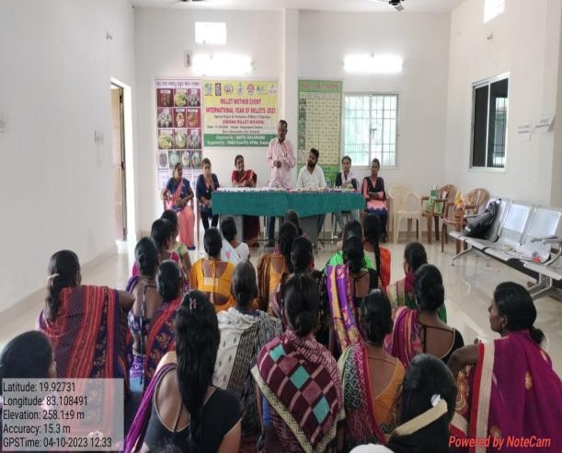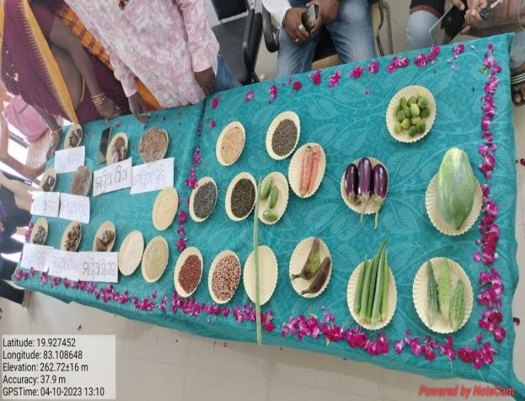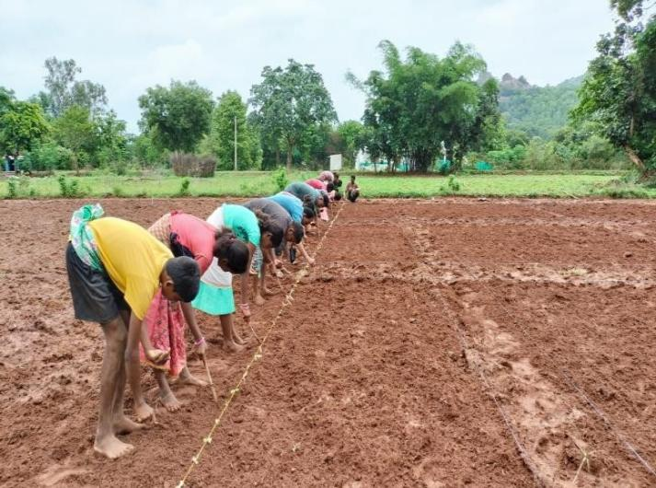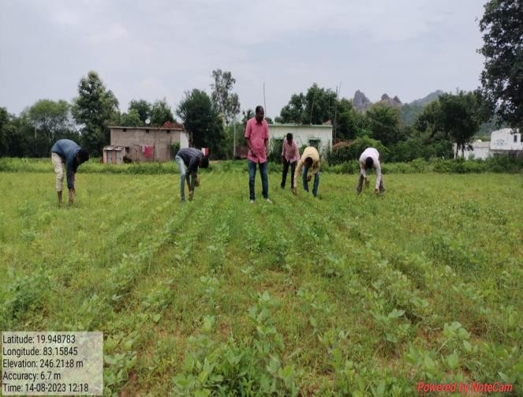

Quality Primary Education for Tribal Children in remote village
Supported by Smile Foundation

PROJECT BRIEF
Under the project support, the Mission Education (ME) Centre- at Kanarla, Bikasnagar, Dahanipadar, Sorpadar of Kalahandi, Odisha has been filling the gap in education to 150 underprivileged and Tribal children belong to PVTG categories. Almost all the children are enrol in Government school and we also help in enrolment tribal children. All the children live in Tribal village of Kanarla, Bikasnagar, Dahanipadar, Sorpadar of Langigarh Block with poor socio-economic background and lack of basic life amenities. The summary of the project is given below:

Total no. of Student | 150
Type of Educational Support | Supportive Education and filling gap in education
Classes Support | 1st to 9th
Curriculum followed | Odisha State Board
Girl boy Ratio | 45:55
Teacher Student Ratio | 1:30
Age group | 5 years to 14 years
Centre Timing | Monday to Friday 7:00AM to 11:00AM and Saturday 2:30 PM to 5:30 PM

Class/Gender break up of supported Beneficiaries

Class | No. of Girl student | No. of Boys Student
1st | 09 | 06
2nd | 15 | 18
3rd | 09 | 18
4th | 10 | 11
5th | 15 | 17
6th | 02 | 00
7th | 04 | 05
8th | 00 | 03
9th | 04 | 04
TOTAL | 68 | 82

KEY HIGHLIGHTS OF THE PROJECT (2022-2023)
- The Average attendance of children and teachers were 75% and 90% respectively.
- Total 300 Curriculum days conducted during the reporting period
- Republic day, saraswatipuja Puja, Ganesh Puja, Childrens Day, Dipawali and Value education program on Respect, Cleanliness drive were conducted.
The Mission Education program was implemented in a holistic way wherein, our program fill the gap what left in School, through our program we not only giving education but we help them to improve in sports, dance, co-curricular and extra-curricular activities like Drawing class and Dance class was organised to ensure the overall growth and development of the children. In the period from April 2022 to March 2023, the following major activities were organized at the ME centre of Kanarla, Bikasnagar, Dahanipadar, Sorpadar.

TEACHING LEARNING ACTIVITIES REGULAR CLASS
As our Program is a supportive or value addition to already school going children who lacks in understanding and reading books, doing basic numeracy like add, subtract, multiply, division, LCM, HCF etc. Teacher are only help them to cover their school syllabus, where he or she didn’t understand in school that was fully covered by teachers of all ME centre.
As our centre in the tribal area of PVTG community
Where the literacy rate was very low. Parents of the children are not so much aware about education.
Teacher of our Four centre was also from their local area, he explain the student in their local language.
- Methodologies like Story Telling, Quizzing, Group learning etc. was followed to make teaching-learning more participative for primary and upper primary students through cluster classes in community.
- Age specific learning was encouraged to improve the holistic development of each child.
- Teachers emphasized their method of teaching in activity-based manner wherein the students participated rigorously and bring about efficient learning experiences.
- The teachers provide special attention to the slow learners to improve their learning levels and help them get along with the other children
- Regular teaching and revision of the subjects, like Mathematics, English, Environmental Science, Social Science, Science, Language Odia etc. as per the curriculum under state board following child-centric and participatory methodology to facilitate the requisite upgradation of the learning.

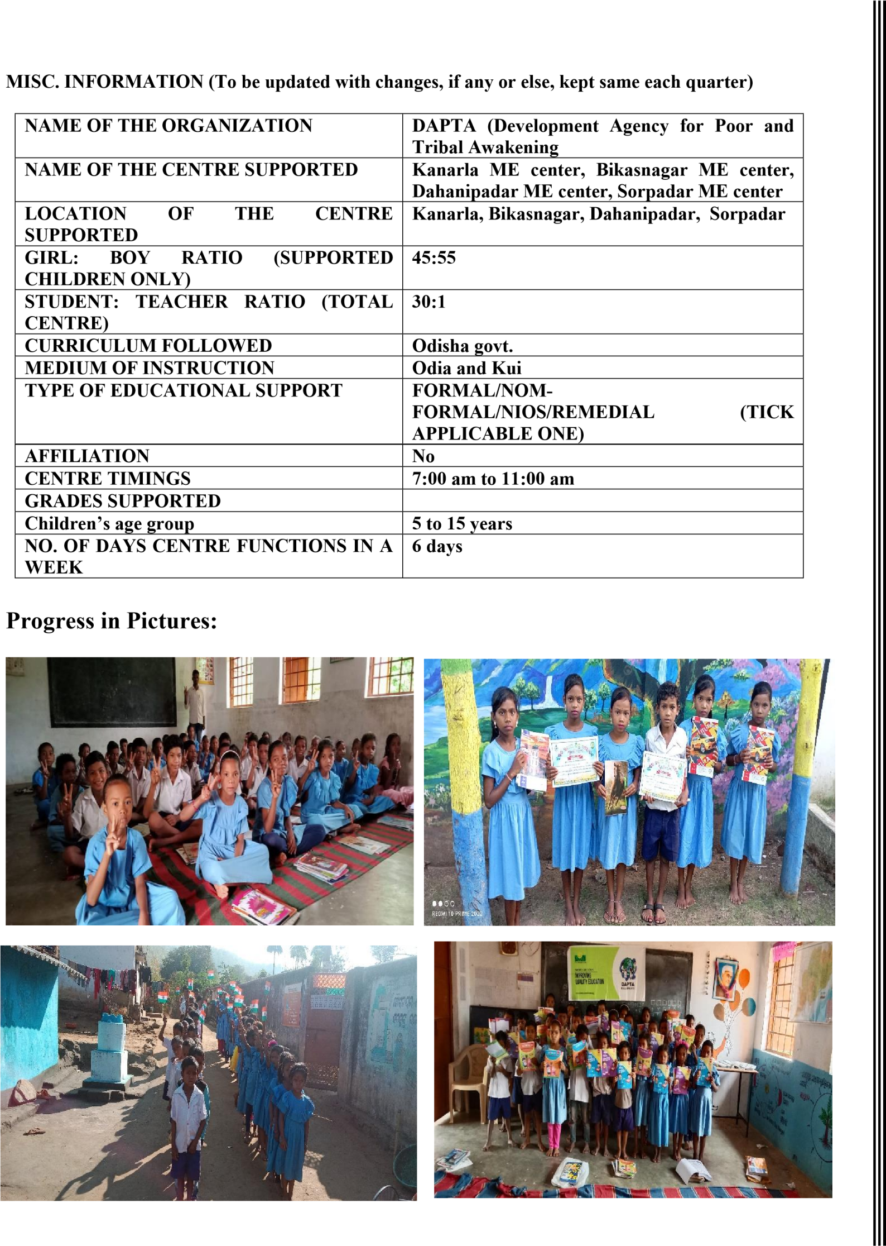

Ensuring food and livelihood security of
indigenous and other marginalized communities

Supported by MCC

The project started from 1st June, 2023 in 7 villages of Thakurmunda Block of Mayurbhanj District. All the villages except Kisunsahi are inhabited by the “Ho” tribe, one of the most deprived communities in Odisha. Kisunsahi is inhabited by the “Santhal” tribe. The socio-economic conditions of a majority of the households (90%) is poor and they fall under the Below Poverty Line (BPL) category. They have limited access to development and social security schemes of Government.
During the last year of the project, we have conducted 56 VDC meetings. Throughout these meetings, we thoroughly outlined meeting agendas, selection procedures, and the criteria required for providing support. Each session was dedicated to transparently discussing and clarifying these essential aspects, ensuring clarity and understanding among all participants. Women and youths were prioritized as participants in the meetings, actively engaging in discussions and voicing their issues and concerns. They demonstrated leadership within the village meetings, contributing significantly to identifying their issues.

Villages | No.  HHs | of | Total Participants of VDC meetings |  | Average No. of Participants attended VDC meetings
 |  |  | M | F | M | F
Guhaldihi | 65 |  | 156 | 155 | 26 | 26
Kisunsahi | 48 |  | 137 | 121 | 23 | 20
Gadashi | 65 |  | 119 | 172 | 20 | 29
Mukundiapada | 60 |  | 185 | 99 | 31 | 17
Bapalsahi | 84 |  | 233 | 175 | 39 | 29
Baunsadiha | 70 |  | 197 | 146 | 33 | 25
Maniksahi | 45 |  | 121 | 135 | 20 | 23

Activities | Place | Date | Participants
Training on improved agriculture methods and Technology | DAPTA office  Thakurmunda,  Mayurbhanj | 11.01.2024 | F-8,  M-12
Training on Natural Resource  Management | DAPTA office  Thakurmunda,  Mayurbhanj | 30.10.2023  25.01. 2024 | F-20 M-15
Exposure visit of farmers for adoption of new technology in agriculture | Padmapur village in Keonjhar District | 23.02.2024 | F-14 M-21
Training to the CBO’s (SHG) | DAPTA office Thakurmunda, | 27.12. 2023  27.03.2024 | F-35
 | Mayurbhanj
Trainings on Alternate Livelihood Options: Poultry & Goat Rearing | DAPTA office  Thakurmunda,  Mayurbhanj | 29.12.2023 | F-06 M-29
Training on primary treatments and Vaccination for the domestic animals | DAPTA office  Thakurmunda,  Mayurbhanj | 17.3.2024 to  18.3.2024 | F-01, M-20
Vaccination and medication to the domestic animals |  | 9.10.2023 to  17.10. 2023  19.03.2024 to  25.03. 2024
Training of on Govt. programs, Schemes related to food,  livelihood and social security schemes | DAPTA office  Thakurmunda,  Mayurbhanj | 28.12 2023  09.03.2024  16.03.2024 | F-56 M-49

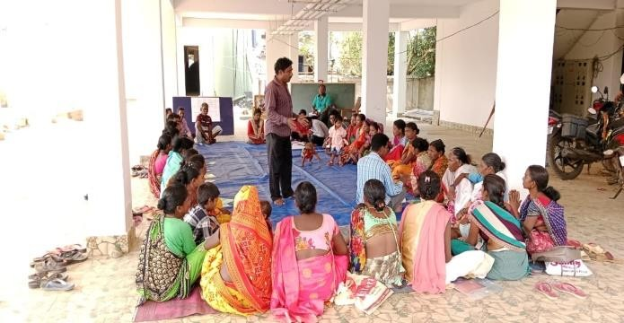
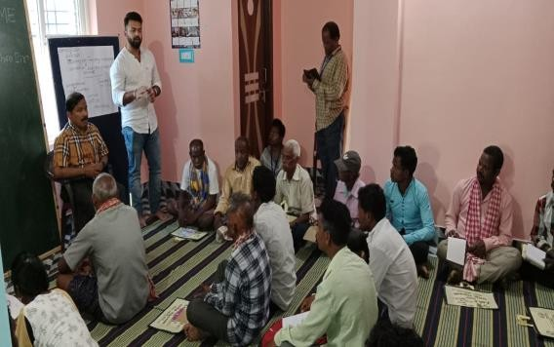
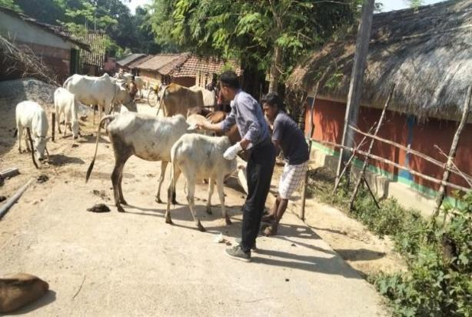
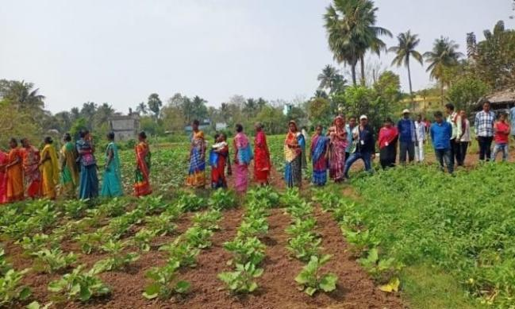
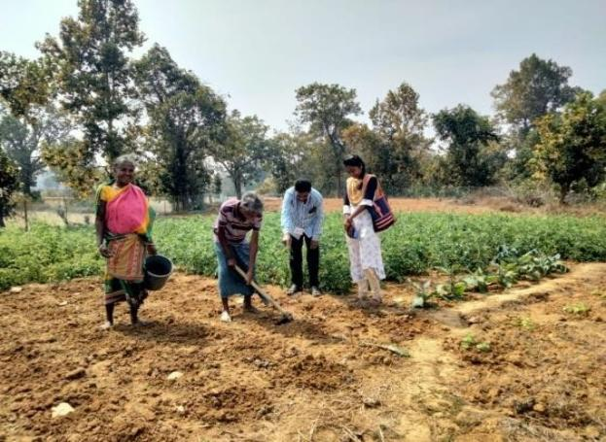
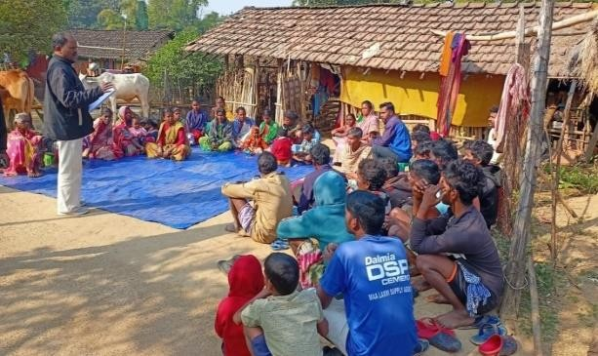

Promoting Women’s organizations to Combat domestic violence and trafficking

Supported by Swiss League of Catholic women (SLCW)

Aim: Empower women and girls to combat Domestic violence, Trafficking and Protection of Girl Child in Kalahandi district of Odisha Specific Objectives:
- To support community-led collective actions to ensure focused attention in dealing with offences of domestic violence and human trafficking.
- To ensure victim-centric approach which takes into account the best interest of the victim/survivor and prevents secondary victimization/re-victimization' of the victim.
- To ensure a gender sensitive and child rights sensitive approach in dealing with the victims of domestic violence and Trafficking.
- To facilitate inter-departmental collaboration among the Police and all other Government agencies and Departments such as CHILDLINE, DCPU, Child Welfare Committee, Women & Child, Labour, Health and the civil society.
Target groups: The targeted beneficiaries include women, adolescent girls, men from the most marginalized Tribal, Dalit and Other Backward Classes and other most vulnerable communities, Panchayati Raj Institutions (PRI) members (Local Self Governance bodies) and other relevant duty bearers in Kalahandi district, Odisha.
Geographical Coverage: Direct project interventions in 3 Gram Panchayats Namely Kamthana, Karlaguda and Palsijharan in Bhawanipatna Block of Kalahandi district, Odisha. The indirect coverage will be the entire district of Kalahandi.
Vocational Tailoring Center: We have a Vocational Tailoring Center(Tailoring) at Ghusurigudi of Palsijharan Gp of Bhawanipatna Sadar block. 78 women and Adolescents girls have completed tailoring training. Some of them produced petticoats and sold them in the local market and earned. Other activities: In an effort to address the issue of school dropout, we successfully re-enrolled seven girls in Gananathpur High School in the Bhawanipatna Sadar Block.
one orphan child was linked to a shelter at Josoda Child Care Institution in Dharamagard Block, providing a safe and supportive environment
We were able to prevent 2 cases of child marriage with the collaboration and support of CHILDLINE, the Police, DCPU, CWC, and ICDS.
18 cases of domestic violence from various GPs in the Kalahandi District. Through the counseling, some cases were successfully resolved, while others are still under process Furthermore. 8 children linked under the Ashrivad Yojana

Sl no | Program | Place | No of program
1 | Campaign of girl’s education, Save girl child, Child marriage and protection of girl child. | Dumal | 1
2 | Thematic Training on ITPA,JJ  Act,PCMA, POSCO AND DV Act | DAPTA Conference Hall | 1

3 | Training of Adolescent Girls groups on leadership ,Live skill education , Menstural hygine and Hiv. | DAPTA conference hall | 1
4 | Lesioning &Networking with PRI, Govt authorities &CSO,NGOs . | Kamthana GP,  KarlagudaGP and  Palsijharan GP | 3
5 | Formation and Strengthening of women forum | Palsijharan ,Karlaguda and Kamthana | 3
6 | Campaign on Domesic Violence and  Anti trafficking | Palsijharan | 1
7 | Awareness meeting on Domestic violence and Trafficing Women's Rights, Menstrual Hygiene,  Sunstroke, Government Schemes,  HIV/AIDS, Social Security Schemes,  Child Marriage, and Migration with  Adolescent Girls | Bhangabari,Karlasoda,Bor bhatta,Uditnarayanpur,Bail jor,Dumal,Ghumerguda,B adkhairmal,Kamthana,.Pal sijharan,Tentulichuan,Ghu srigudi,Dungipunga,Bhikaj haran,Kholand,Karlaguda, Borguda,Kubdi,Pastipada, Sankhairmal. | 165
8 | Awareness meeting on Domestic violence and Trafficing, Women's Rights, Menstrual Hygiene,  Sunstroke, Government Schemes,  Community Issues, HIV/AIDS, Social Security Schemes, Child  Marriage, and Migration | Bhangabari,Karlasoda,Bor bhatta,Uditnarayanpur,Bail jor,Dumal,Ghumerguda,B adkhairmal,Kamthana,.Pal sijharan,Tentulichuan,Ghu srigudi,Dungipunga,Bhikaj haran,Kholand,Karlaguda, Borguda,Kubdi,Pastipada, Sankhairmal. | 165
9 | Training For Adolescent girls on  Domestic violence and Trafficking . | Bhangabari,Karlasoda,Bor bhatta,Uditnarayanpur,Bail jor,Dumal,Ghumerguda,B adkhairmal,Kamthana,.Pal sijharan,Tentulichuan,Ghu srigudi,Dungipunga,Bhikaj haran,Kholand,Karlaguda, Borguda,Kubdi,Pastipada, Sankhairmal. | 45
10 | Training For Women on Domestic violence and Trafficking | Bhangabari,Karlasoda,Bor bhatta,Uditnarayanpur,Bail jor,Dumal,Ghumerguda,B adkhairmal,Kamthana,.Pal sijharan,Tentulichuan,Ghu srigudi,Dungipunga,Bhikaj haran,Kholand,Karlaguda, Borguda,Kubdi,Pastipada, Sankhairmal. | 45
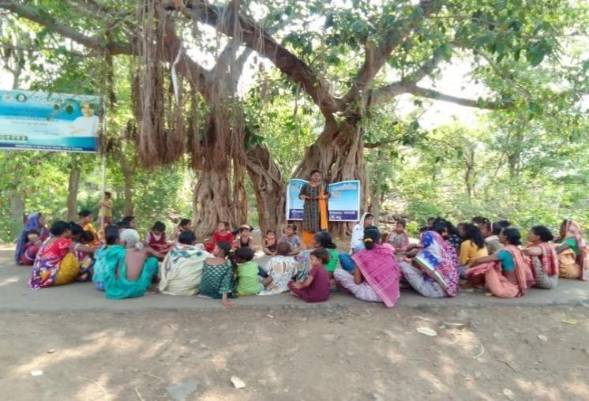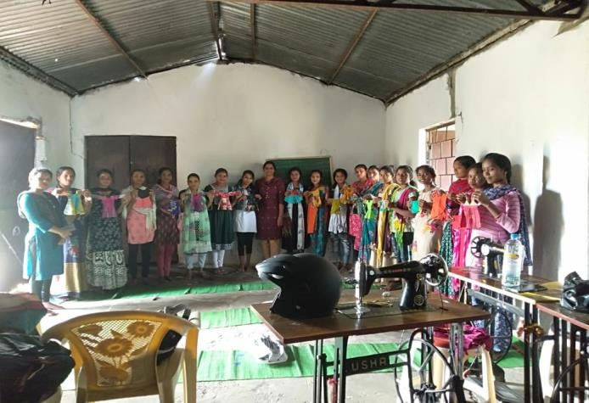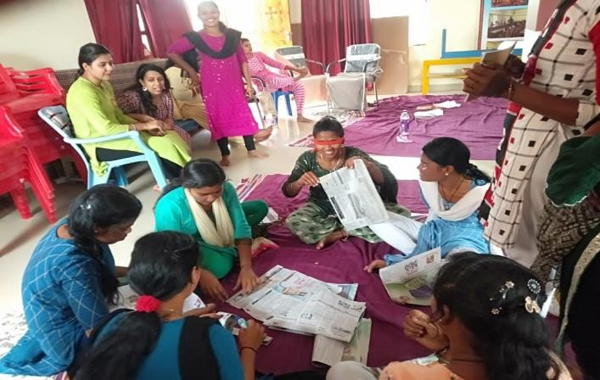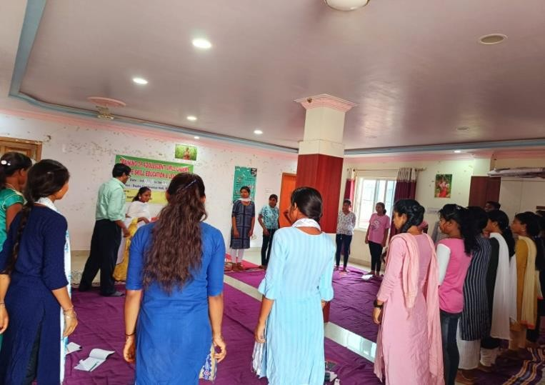
Photo Gallery:

Objectives

FCC (Family counselling center)

Supported by central social welfare board

Covers Kalahandi District

- To provide Preventive, Promotive, and Rehabilative services to women and children who are victims of atrocities and exploitation through Counseling.
- To create awareness about the existing laws related to women and children and provide facilities like free legal Aid, referrals to short stay home, Medical.
- To provide Services to Women and Children in distress through Crises interventions, investigation of disharmony, alcoholism and illness.
- To enable reconciliation and amicable settlements out of court.
Activities
Services for women with problem Like- • Harassment and wife battering
- Exploitation
- Dowry
- Marital disharmony
- Family problem
- Mental illness
- Alcoholism
- Legal aid
- Other Psycho Social problem
Services Provide
- Counselling
- Organizing Awareness Programs in School and Communities.
The purpose of counseling is to help individuals or groups address and resolve personal, social, or psychological difficulties. Counseling provides a supportive and confidential environment where people can talk about their concerns, feelings, and experiences with a trained professional who can help them explore their thoughts and emotions, gain new insights and perspectives, and develop strategies for coping with challenges and achieving their goals. Counseling can help people deal with a wide range of issues, including stress, anxiety, depression, relationship problems, grief and loss, trauma, addiction, and career or educational challenges. The goal of counseling is to empower individuals to make positive changes in their lives, improve their overall well-being, and achieve greater self-awareness and personal growth
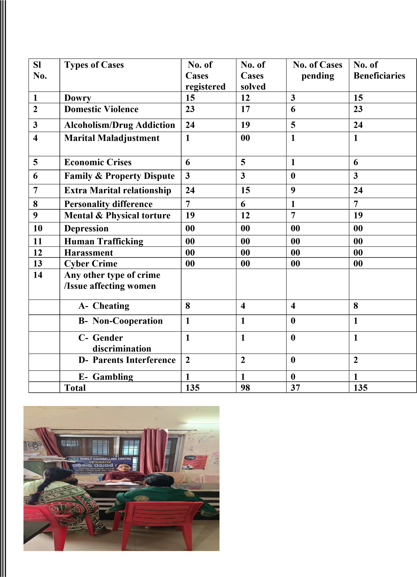
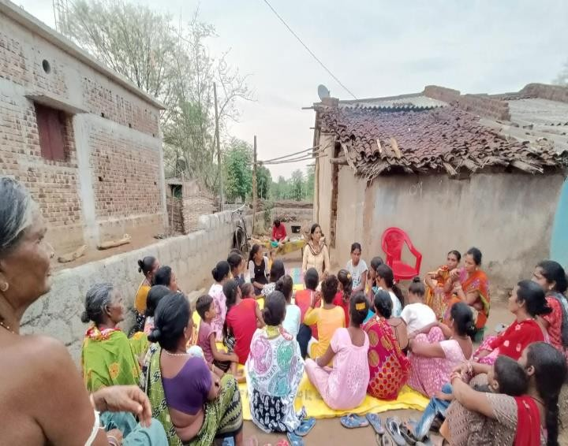

Women in Agriculture
(Strengthening women’s vegetable Grower Cooperatives, Women Farmers Producer Company, LEDP, Rural Mart)

Agriculture is an important component of rural livelihoods. Women play a pivotal role in all agricultural operations from planting-to-harvesting-to-post-harvest operations. Recently government of India has given high priority on ‘Recognition and Mainstreaming of Women’s role in Agriculture ‘through incorporation of ‘pro-women initiatives’ in various Schemes / Program / Missions and earmarking of at least 30% of benefits and resources for women under all such beneficiary-oriented interventions. The FAO reports that abolishing genderspecific barriers in farming, would not only empower women to achieve their highest economic potential, it could help feed a hungry world.
DAPTA has implemented various pro-women program to bring women fore-front in the agricultural sector.
DAPTA has implemented various pro-women program to bring women fore-front in the agricultural sector.
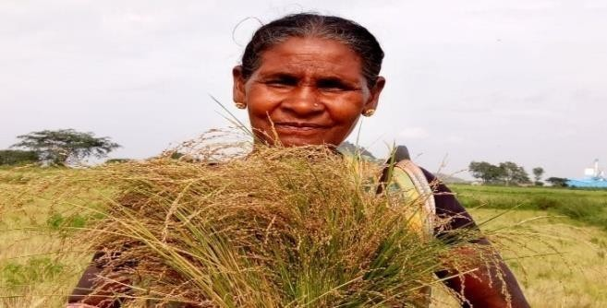 | 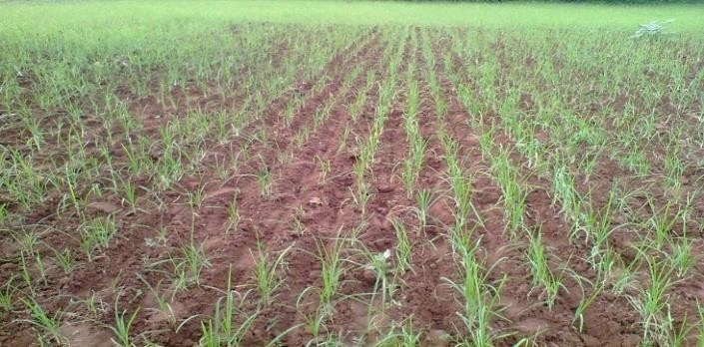
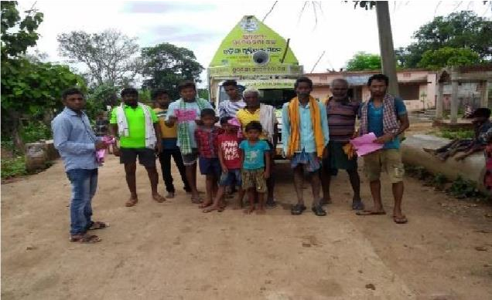 | 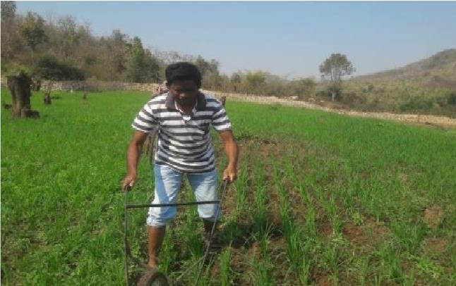

Women Farmers Producer Company

Supported by NABARD

As livelihood is a main focus of our objective, DAPTA is working from very beginning to enhance livelihood standard of poor and marginal farmers through many a farm and off farm base activities. DAPTA promotes women farmers those really struggle to enhance their income. Basing on the ground reality, DAPTA has facilitated to form and strengthen 2 nos. of Women Farmer producer company WFPC those are doing vegetable production, value addition, marketing. One of the companies is engage in millet promotion, value addition and marketing activities. Both the Women farmer’s company are own managed having clear concept. They have prepared their business development plan to go ahead. Now leadership quality and business technique has developed with them and DAPTA is providing hand holding support to gear up.
One of the Women Farmer companies has awarded 2 nos. of Agriculture Project by competing tender process with Agriculture Dept. Govt. of Odisha.
S  l  N o | Company Name | Registration Number | Total  membe  r | Total share capital | Total turnover
1 | Matiputra  WFPCL  management by DAPTA,  Kalahandi | U01114OR2018PTC02  9581 | 501 | 52,100 | 3,50,000
2 | Dukuri women  farmer producer  company  limited | U01100OR2018PTC02 9638 | 502 | 501000 | 4823400

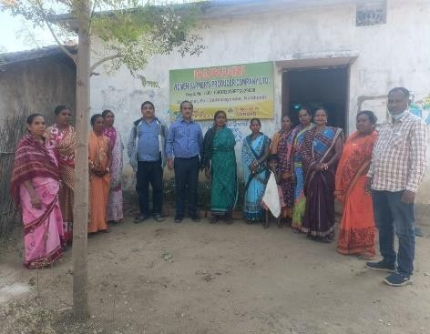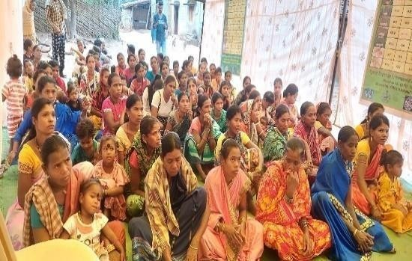

LEDP Training

Supported by NABARD

Introduction
During 2014 DAPTA has started its activities at Tileibani Block with community led Sanitation program. Then DAPTA came in touch with SHG and Women farmers of the Locality.
After discussing with Women farmers and their opinion that technical training on vegetable and Mushroom cultivation can increase their household income, DAPTA submitted proposal to NABARD which got sanctioned and the program started from 1st October,2019 and due to corona, the project ended in little late. In this training, we provided training to 90 women farmers on Vegetable Cultivation and 30 Women farmers on Mushroom Cultivation with need base demonstration.
Objective of the project
The objective of the project was to increase house hold income of Women farmers through farm base activities.
Another objective was to facilitate Women farmers to link with financial institution, market and convergency link with different line department.
The overall objective is to strengthen income generation of Women farmers those will be able to lead a meaningful life.
Methodology of the project
The methodology was to provide in house training to farmers in two phase like phase one and refresher training of 2 days in the mid intervention. Besides that, training will follow by a need base demonstration. Handholding support will be provided to SHG for bank linkage.
Expected Deliverables of the project
- The Deliverables of the Project was to Provide training to 120 Women farmers.
- 90 farmers will be trained on different Vegetable cultivation.
- 30 farmers will be trained on mushroom cultivation.
- Farmers will link with financial institution and their income will be enhance.
1. Implementation Process
- Identification of potential beneficiary • Social mobilization and Village level meeting
- Demonstration unit.

Conduct of Skill development and Training program (type of training program, involvement of institutes of repute or Govt, line departments, trainer details in brief)
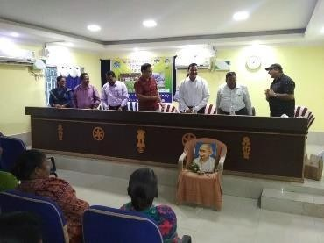
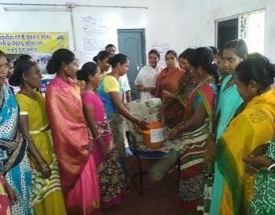
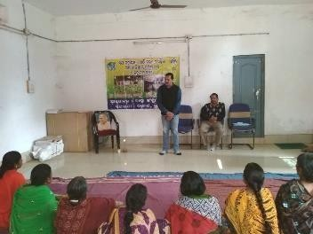
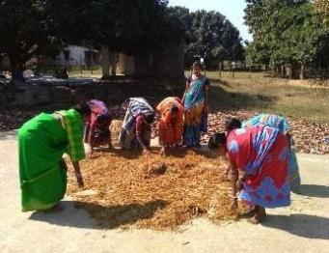
a.

Strengthening

of

WSHGs

b.

Credit

linkages

with

banks

2.

Monitoring

and

Hand

holding

support

3.

Convergence

with

Line

Departments

4.

Outcome

of

the

project

90

Women

farmers

trained

on

vegetable

cultivation

30

Women

farmers trained

on

Mushroom

Cultivation.

All

120
Women

farmers

are

practicing

in

field

and

their

income

has

enhanced.

All

are

linked

with

Bank

through

their

respective

SHG.

50
%

income

has

enhanced

from

their

earlier

income.

RURAL MART

Supported by NABARD

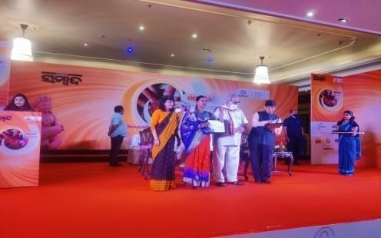
BRIEF REPORT OF RURAL MART
Name of the FPO- Matiputra Women
Farmer’s Producer Company Limited
Facilitating Agency - DAPTA
Kalahandi. Support by – NABARD, Bhubaneswar
A. Project title: Setting up of Marketing
Outlet at Bhawanipatna, Kalahandi

- Project Area: G.P.- Medinipur and Gudialipadar Block- Bhawanipatna Dist.- Kalahandi.
- Details of beneficiaries: 501 no’s of Small & Marginal Women Farmer’s.
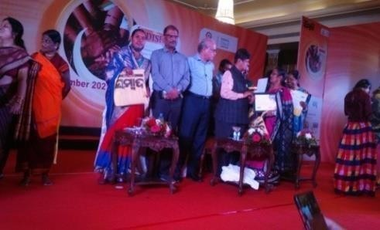
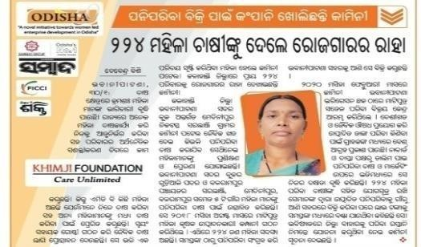
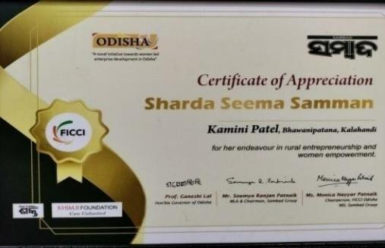
- Brief Introduction of project: In the year 32 no. of SHGs came together and formed a farmer producer company named Matiputra Women Farmer Producer Company Limited (MWFPCL). Initially the total membership was 250 in the initial period which increase later on. Now there are 501 women farmers in the company. Most of them are vegetable producers and they used to produce vegetables round the year. Marketing was one of the biggest issues for them. Since it is a perishable item sometimes Bhawanipatna manage a Rural Mart. Sometimes the loss becomes unbearable for the farmers. There is no such provision either by government or any private agency for proper storage of the produces/ vegetables. Bhawanipatna is the nearest market place about 12 km. Since marketing was the major challenge most of the time the members was struggling to get out of the challenge. Finally on dt. 10.09.2019 it was decided to approach NABARD to support the company in order to market their produces in Bhawanipatna. On dt.20.11.2019 NABARD supported the Rural Mart to MWFPCL and was inaugurated on dt. 06.02.2020 by the MLA Bhawanipatna and leader of opposition Mr. Pradipta Naik in the presence of DDM NABARD Malaya Kumar Meher and the same Rural Mart outlet is continuing now. The Matiputra Women Farmer Company has awarded SHARADA SEEMA SAMMAN in Odisha by the Governor of Odisha.

Improving the Self-Reliance and Resilience of Rural Communities

Supported by Reliance Foundation

PROJECT AIM:
The project will help to improve climate adaptive farming practices, end malnutrition by adopting nutritional backyard kitchen garden, conservation and management of water, improving existing livelihood for better income generation of rural communities and strengthen food security in the district of Kalahandi.

Area of intervention:
Bhawanipatna Block |  | Lanjigarh Block |  | Th.rampur Block
Name of the GP | Total villages | Name of the GP | Total villages | Name of the GP | Total villages
Gudialipadar | 06 | Bengaon | 07
Medinipur | 01 | Lanjee | 09 | Gopalpur | 05
Thuapadar | 03 | Bhatangpadar | 08 | Thuamul | 05
Kamthana | 05 | Lakhbahali | 05 | - | -
Karlaguda | 02 | Kankutru | 03 | - | -
Malgaon | 02 | Bedagaon | 01 | - | -
Risigaon | 05 | - | - | - | -

Our targeted groups:
- Women SHG Members.
- Marginal farmers and Landless Household
- Small, marginal and advanced farmers
- PVTG and Dalit
- VSS and targeted individual households

Activities | Annual Target | Annual  Achievement
1.1-Villages initiated climate resilience measures and integrated into village/Gram Panchayat Development Plan | 26 | 26
2.1-Villages conducted participatory assessment of common resources and creating management plan | 51 | 50
2.2-Additional water harvesting capacity created | 3 | 3.0384
2.3-Area brought under efficient management of water | 100 | 107.79
2.4-Area covered with conservation and restoration of common resources | 125 | 120.8
2.5-Villages with improved access to drinking water | 20 | 20
2.6-Households engaged in grey water management | 328 | 328
2.7-Area brought under climate adaptive farming practices (soil | 785 | 816.24
fertility improvement, resistant seed, intercrop, trap crops and INM)
3.1-Households with diversified food production and consumption | 828 | 819
3.2-Area covered under nutrition rich and bio fortified crops | 42 | 41.91
4.1-Area under improved production practices/new agriculture technologies | 780 | 745.82
4.2-Farmers adopting and benefitting with improved practices and/or new agriculture technologies | 893 | 776
5.1-Farmer collectives (FPOs/ SHG Federations/Co-op/ PACS/ Informal group of farmers) provided techno-managerial support and/or linkages | 3 | 1
5.2-Producers benefitting from marketing of their produce / accessing products and services from Farmer Collectives | 697 | 1319
5.3-Value of produce marketed and inputs/services sourced through farmer collectives | 2
6.1-No. of SHGs/ Producer Groups / Collectives (Men &  Women) engaged for income enhancement | 150 | 151
6.2-Persons supported to improve existing livelihood / Persons supported in taking up additional livelihood in Farm & Non-  Farm Sector | 1130 | 1183
7.1-Improved access to entitlements, schemes and financial products for financial inclusion | 841 | 830
7.2-Women with improved digital and financial literacy engaged in livelihood activities | 841 | 794

Case Study:

“Water is life”, DBI for providing drinking water.

Litibandel is a village of Bengaon GP, Lanjigarh block is situated at a distance of 58km distance from Dist. head quarter. The village is a remote tribal area with 80% PVTG & 20% SC community consisting of 98 household in 4 pada. Its total population is 493, the livelihood of the people of Litibandel depends upon farming, labour and forest products. They cultivate different type of millets, paddy, pulses and vegetables for their livelihood. There are certain issues faced by the villagers in the particular area such as education, health, communication, and drinking water which is the most essential yet difficult to acquire it in drinking form.

The village has handpumps, among which one is de-functioned and an open well which is mostly dry and the water quality is very much poor for consumption purpose. In summers, water scarcity gets very high. The village has one natural water point as the only water source for the village Litibandel, which is perennial and provides water during summer and also throughout the year but it is not safe for drinking purpose. The point is situated 0.5km far from the village, which is situated at the bottom of village forest and beneath the foot of a hill.

In the year 2023 Reliance Foundation intervened the village Litibandel with DAPTA. A VDC meeting was held, where the residing community shared their main problem which was ‘drinking water’ and suggested for a construction of DBI at the perennial water point for supplying drinking water through pipe line at the household level.

The team DAPTA with Reliance Foundation team and experts visited the site multiple times, for survey, feasibility for the pilot project of DBI and accordingly finalized the construction plan. The DBI work has started with the support and guidance of Reliance Foundation. The residing village People helped with contribution through labour work. Before starting the work, the villagers requested DAPTA for the construction of DBI through No Objection Certificate from the gram panchayat office, Bengaon.

The DBI work has been accomplished successfully by DAPTA with the help of Ms Narayanee Enterprises, Bhawanipatna. Also, with the help of experts from Reliance Foundation and the JE, in the year 2024. In the DBI site, DAPTA has completed constructing ‘one concrete intake chamber for water storage, installation of filter in the DBI system for purified and good water quality supply, for drinking and consumption purpose. Water is being supplied through the pipe lines to 3 water stand posts for 3 padas, covering 98 households.

The DBI will be very helpful in various ways for the villagers as a change in livelihood, health and hygiene, backyard kitchen garden and drudgery reduction. The DBI provided good quality drinking water throughout the year and simultaneously it will be helpful for people’s health from water borne diseases and promotion of backyard kitchen garden in future.

The village people were extremely delighted, pleased and thanked team DAPTA, Reliance Foundation, Ms. Narayanee enterprises and all the experts in this work for their noble support and timely completing the project.

“Save Water Save life”
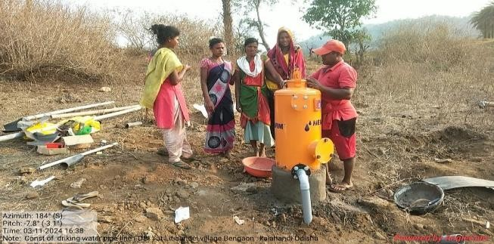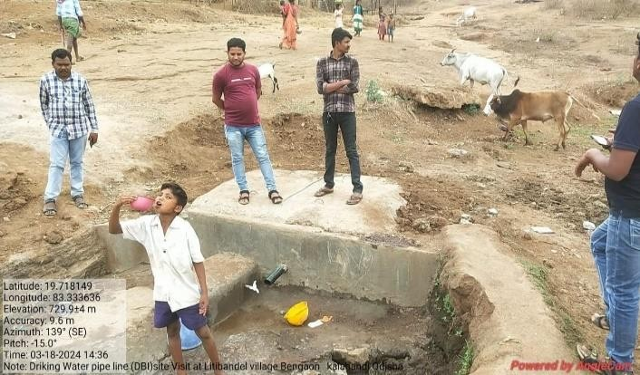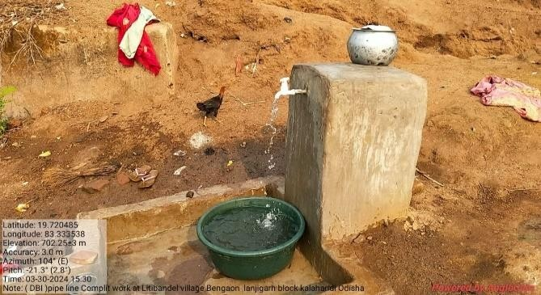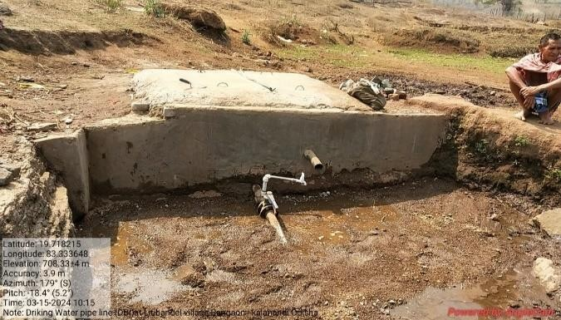

Title: The Inspiring Journey of a Young Tailor
Background:
Miss Subarani Bagarti, a 19 -year-old girl from a small Village Badkhairmal in Kamthana GP of Bhawanipatna Block in Kalahandi District , she residing with her small family consist of six person her Father – Mr. Rabin Bagarti, Mother –Tulsa Bagarti , 3 Sisters and one Brother. Her family is fully depend upon her father, the only earned person in the house. He is a Raja Mistry (Skilled labour) by profession.
Subarni always had a passion for sewing from his child hood, after completion her high school education from Kamataha high school. She has got a chance to enrolled in a tailoring course from a vocational training Center at Kamthana in his locality.
The Journey Begins:
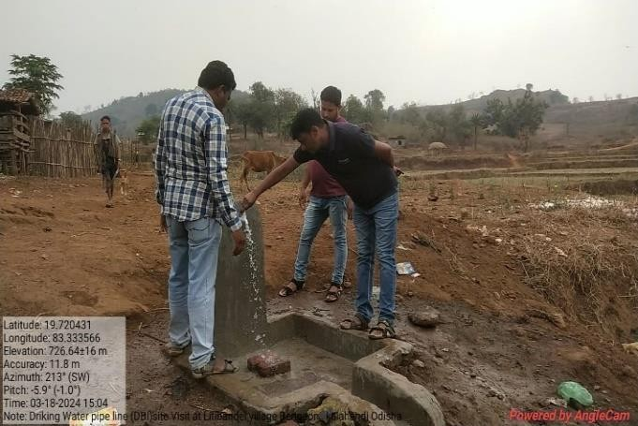
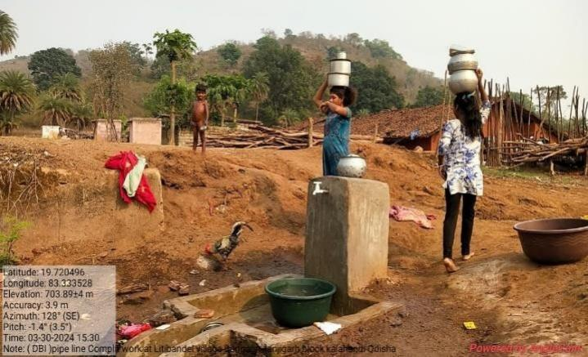
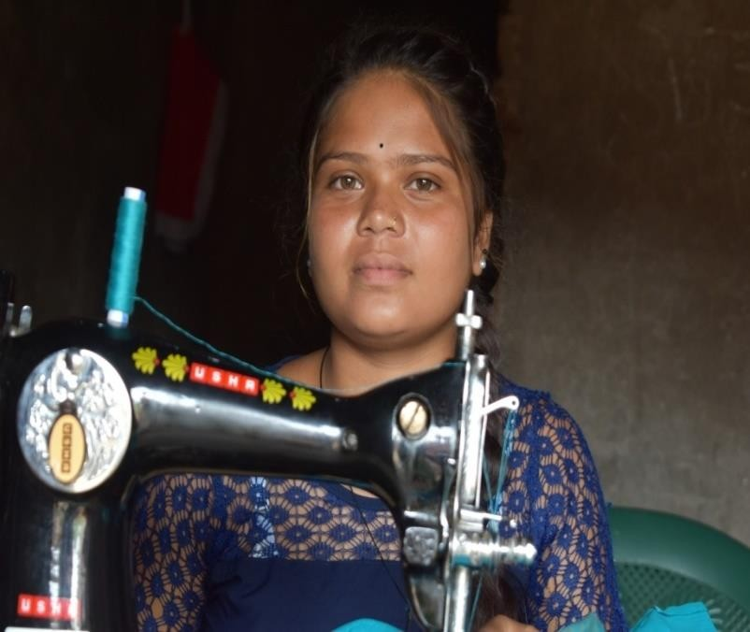
Subarni,s journey in the tailoring course was nothing short of a magic .she has never known that , one day she was count as one of the most efficient student in the skill training class , her dedication, hard work and her quick learner attitude make it possible to became a standout student in the training class. She spent hours for practicing and learning the various stitches techniques associated with the tailoring courses. Her instructors noticed her potentialities and encouraged him to watch some selected YouTube videos on unique designs stretching etc, which was improve her caliberities and ideas in the latter part of the life.
The Turning Point:
After completing her three month vocational course in May 2023, she was decided to set up her own tailoring business at her home. She invested in a basic sewing machine and started taking orders from friends, family and neighbors.
The Rise to Success:
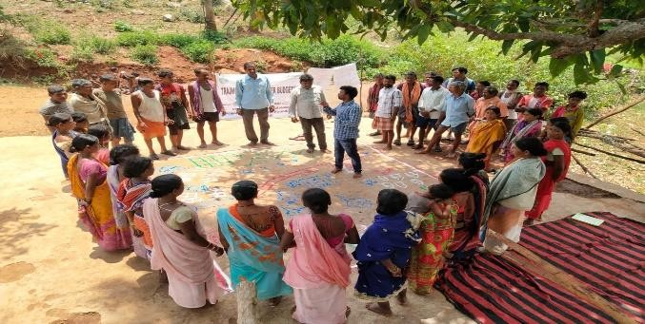
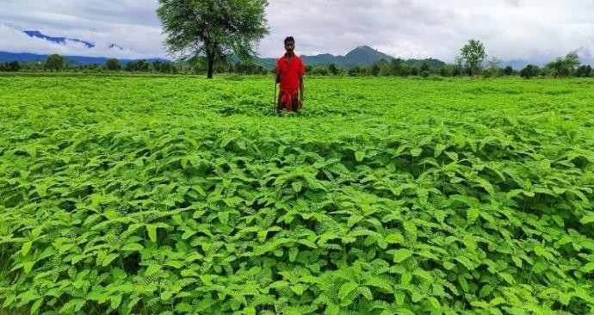
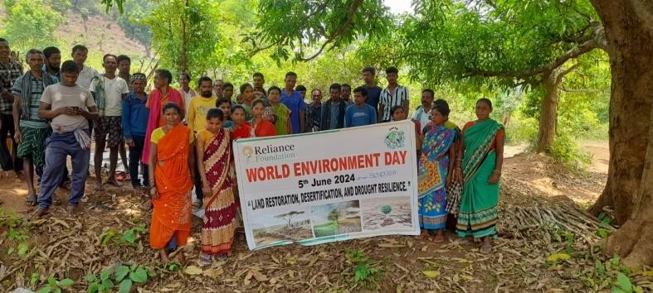
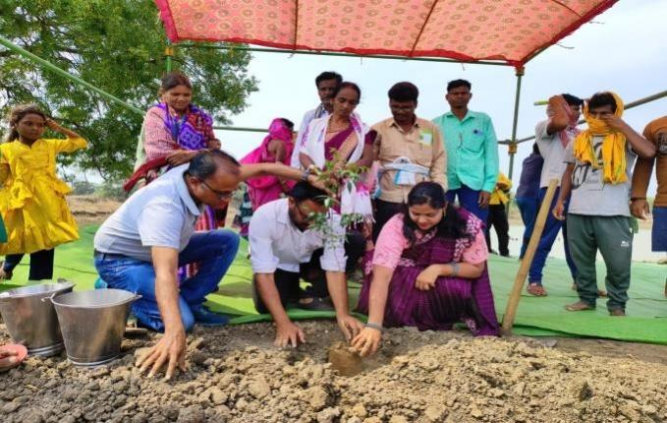
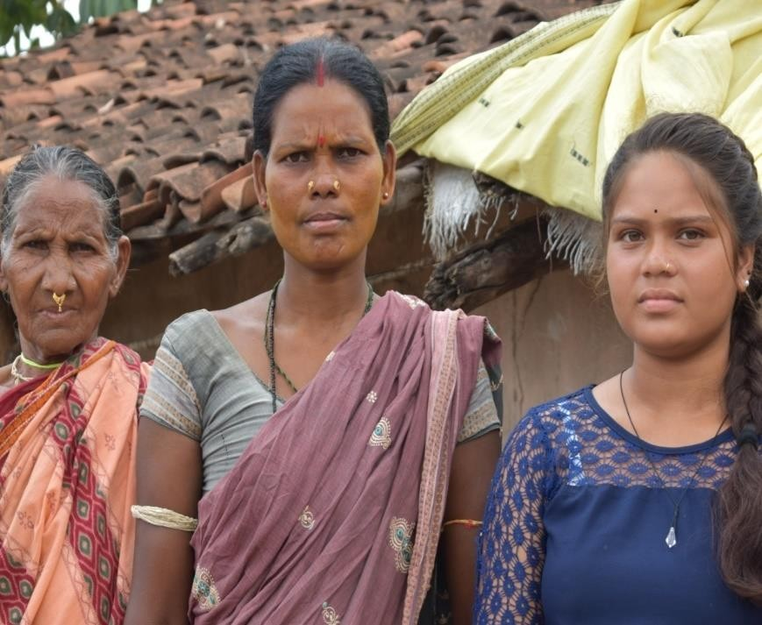
Subarni's big break came, when she
received an order to create a custom
wedding Blouse
for a local client. Her
except
ional work and attention to detail
impressed the client and that Clint referred
her to other potential customers. Soon,
Subarni’s Word drop was full with orders,
and her business started to flourish. She
expanded her services include to repairs,
and custom

clothing designs.

Achievements and Impact:

Now Subarni was able to earn 5,000 to
6000
per month, a significant achievement
for a young entrepreneur in a small
Village. Her success was not only
improved her financial stability but also
empowered her to sup
port her family and
contribute to the local economy. Subarni's story serves as an inspiration to many young girls in her
local community.

Challenges/Lessons Learned Conclusion:

Subarni faced several challenges from her journey, including limited resources, competition from
established tailors etc but
apart

from all the challenges she was able to
manage

her time effectively.
She also emphasizes the importance of learning attitude
and quality customer
behavior

and
services, however, these stories clearly indicate that, if you have a willing power, determination,
dedication then everything will be possible.

Subarni's story is an example for those, who want to
be a self
-
sufficiency

and become a part rural economy.

Progress in pictures:

TDH

SEWOH_EXIT PROJECT

Supported by Terre Des Hommes (TDH), Germany (BMZ)

Objectives: 5063 households in Kalahandi and Rayagada districts are resilient to hunger crisis and are able to advocate for their forest rights with civil society stakeholders at regional and national levels.

We have formed village level farmers committees, women committees, youth committees, children committees and Forest Rights Committees. The committee members are being continuously trained and capacitated on different thematic aspects of livelihood.
- Agroecology training, training on organic manures, soil and water conservation, mushroom cultivation training for women, seed preservation training for farmers and the community has started the application of the gained knowledge and skills. This apart, we have also established seed bank to promote and protect the indigenous and locally available seeds suitable for the sustainable agriculture.1540 HHs are involved in sustainable agriculture. About 40% of farmers now prefer traditional and indigenous seeds for example the small paddy which is known as chhetka, sekra locally is increasingly used by the farmers. This is a short duration paddy and require less water. This can be also grown in moderately up land. Therefore, more lands have come to paddy production fold. Some amount of lands remained earlier barren/ fallow after paddy crop, are now being used either for oilseeds, pulses, vegetables etc.(depending upon the availability of water, moisture content etc.)
- Seed given to the seed bank, is being used by the targeted farmers, they are multiplying and giving back to the bank as per their terms and condition. Again, the seed to be used to cover more farmers in the succeeding season. Around 259 HHs are involved in this activity.
- Nutri-garden support is given to 500 HHs which is immensely contributing in enhancing their nutritional status. By seeing the success, about another 500 farmers have made their own nutrigarden on their own cost by getting inspired from the supported nutri-garden. Earlier getting greens and vegetables in the operational area was day dream like. But the scenario is gradually changing and vegetable can be found almost in all the villages. Consumption of greens and vegetable at the household level has been visibly increased. Taking the advantage of the new scenario, we are educating Apart from agriculture, we have also given training on ethnoveterinary to ensure the goatery and poultry more remunerative which one of the major productive assets of the targeted villages and community. People say, after the ethnoveterinary training they are able to reduce the mortality and morbidity rate of the goats applying their gained knowledge and skills. We are continuously engaged with the targeted goatery farmers to take up goatery on an enterprise mode.175 HHs so far practicing the ethno- veterinary ways, so they now able to save from expenditure in the way of purchase different types of chemicals.
- Series of engagements with the women and youths aiming to increase their access to the government schemes and provisions has also remained one of the focused interventions. In one hand, efforts are being taken to increase the production and in the other hand, we are empowering farmers, youths and women to access different developmental schemes and provisions of the government.
- FRCs have been formed with an aim to have the ownership of their forest which is also one of the substantial sources for their food security and nutrition. About, 2000 HHs are now involved in 48 FRCs. Now, CFR of 3 villages have submitted to the SDLC, 29 villages are now under the process of filling claims for CFR and IFR. and joint verification notice has been sent for 5 FRCs.
- 2 Youth committees from Serkajola and Pahadpadar villages are protecting their forest as result of the continuous engagement with the youth committees. They are interested to make their forest more remunerative.
- The empowered youth committees and villagers are now increasingly coming forward to identify the issues of their communities, prioritizing the issues and put forth the issues before the relevant authority for the redressal. Youths now attended in the special gram sabhas in August and October in 8 GPs.
- 1119 youths and children of 45 villages were involved in activities leading towards clean environment by way of conducting rallies, village cleaning, group discussion and meetings.
- Community demand for the service delivery is gradually increasing. Thus, access to and realization of entitlements is also increasing.
- Increased knowledge, understanding, skill, capacity and increased access contributing towards the community resilience to fight hunger, malnutrition, and climate change effect.
- during the period. As result the targeted youth are increasingly participating in their community development activities and in the local governance. They are actively identifying the issues of their community and taking forward those issues to the appropriate authorities i.e. gram panchayat, lined departments etc for the redressal. The total no of members in the youth groups is 581 out of which 308 are boys and 273 are girls.
- A 3-day state level youth workshop organized in Bhawanipatna jointly by DAPTA, Kalahandi and Lakegarden Kolkata. Total participants were 55 out of which 23 youth from Lanjigarh block.
- 19 youths from Lanjigarh block participated in a state level youth workshop organized by Living farm,Rayagada
- Two youth from Lanjigarh participated in a national level conference in sundarban organized by Lakegarden, Kolkata.
- Two youth from Lanjigarh block participated in a national level youth consultation workshop organized by Aman trust, Almoda in VYK, New Delhi.
- 2 village youth from DAPTA participated in a programme called youth for water in Bhubaneswar organised by UNICEF.
- Post COVID counseling session organized in 6 nos of schools covering 233 students (124 boys, 109 girls) by external Resource persons. The objective of the counseling session was to manage and minimize the stress of the students.
- World Water Day was observed in 18 project villages to spread and propagate the importance of water resource and its efficient utilization and conservation where 487 youths and children actively participated.
- Voice for Green Earth was observed in 29 project villages where 795 youths and children actively participated.
- Global action month was observed in 42 villages with 842 participants (454M, 388F). The closing ceremony of GAM was held in Bengaon where 100 children from different villages participated.
- World Earth Day observed at village level with 883 children and youths. The key messages in the observation were how to protect the soil and its fertility, how to maintain and keep intact its bio diversity, its flora and fauna, how to conserve its natural resources and minerals.
- 28 FRCs constituted and 20 FRCs reconstituted in 50 villages, two small villages being merged with nearby big villages.

Sl no | Programme | Numbers
1 | A four-days bio-diversity database training programme (two-day class room teaching and twoday practical) was conducted | 1 training
2 | The existing 25 farmers groups convened for 219 times to discuss various issues related to agriculture. | 219 meetings
3 | Imparted training on agro ecology to 75 | 3 batch
4 | 259 women farmers from 6 GPs undergone training on seeds preservation techniques | 1 training
5 | Seed banks | 13 farmers group
6 | materials to promote nutrigarden procured for 500 farmers and distributed among 500 farmers | 8Acr
7 | Organic fertiliser/ manure training for 69 CRPs in two batches was organized | 1 training
8 | Poultry farming - Capacity building o farmers by CRPs on ethno veterinary | 400 Farmers
9 | Two days Mushroom cultivation training for women farmers organized in 3 batch | 159 women Farmer
10 | 3-day Soil and water conservation training organized | 2 batches
11 | women groups with 334 members have been formed | 20 women groups formed
12 | Gender related issues and gender equity in two sessions held | 50 Farmers
13 | A training programme on food security and agricultural schemes of government organized | 1 Training
14 | District level dialogue on food sovereignty was organized | 1 District Level
15 | 2- day training programme was held in the month of  October’ | 30 AWW
16 | Second Phase of Post COVID nutritional counselling session organized | 6 School

Project Background

Sightsavers

Supported by Madison

The project envisages to collaborate with Tanya Computer Centre (TCC) and establish training centres across 6 states and 10 potential locations of India, where Sights Savers has been working for a long time. With this, the project aims to provide a free & certified computer training course to people with visual impairment who are above 15th years of age group and belongs to poor and disadvantage communities.

Objectives
- To build capacities of people with visual disabilities in digital literacy in the potential locations
- To enhance the confidence and communication skills of the target group through personality development sessions
- To create a scope for the people with visual disabilities to get meaningful employment opportunities in their local area.

Target group: People with Visual Impairment above 15 years of age group.

Target Locations: Bhawanipatna, Kalahandi

Expected Outcomes
- Building capacities of PwDs in digital literacy and promoting personality development among them.
- Improved confidence level and communication skills of the target group
- Creating a scope for PwDs to get meaningful employment opportunities after schooling.
Introduction
SightSavers with support from Madison
Resource Foundation inaugurated Tanya Computer Centre (TCC) that will serve as the home to the Digital Literacy and Internet Awareness Course for children with visual impairment (CVI) in district Kalahandi of Odisha in collaboration with DAPTA. The centre was formally inaugurated by the district social security officer (DSSO), Kalahandi on 13th October 2022.

Tanya Computer Centre aims to provide a free and certified computer training course to children with visual impairment (CVI), above 15 years of age and belonging to poor and disadvantage communities. This centre is initiated to build the capacities of CVI in digital literacy and personality development. Apart from computer skills, the centre will also impart training in spoken English, personality development, health & hygiene, mobility & daily living skills. It is envisaged that the course provided in the centre will help in enhancing the confidence and communication skills of CVIs. It will equip them with required skills, tools, and assistance they need to earn a living and lead an independent life with dignity.
About the Centre

Approach to initiate the Computer Centre

The programme is implemented in Kalahandi District where SightSavers three national programmes are being implemented namely Social Inclusion, Inclusive Education and Rural Eye Health programme. This Computer education programme is integrated within these national programmes as the students selected are beneficiaries of our Inclusion activities in the district. Partner implementing TCC is already running rural eye health projects here and have a good presence & linkages with various stakeholders. As a result of the linkages, one of the stakeholders having trading business came forward to provide us rented space for initiating the centre. Keeping in mind of SightSavers safeguarding policy in terms of safety of the students, Accessibility etc, the place was explored in detail & finalised.
In addition, SightSavers oriented all the stakeholders involved in the programme to have a common understanding of TCC. The centre was publicized, and it was well appreciated by all during the inauguration of the programme.

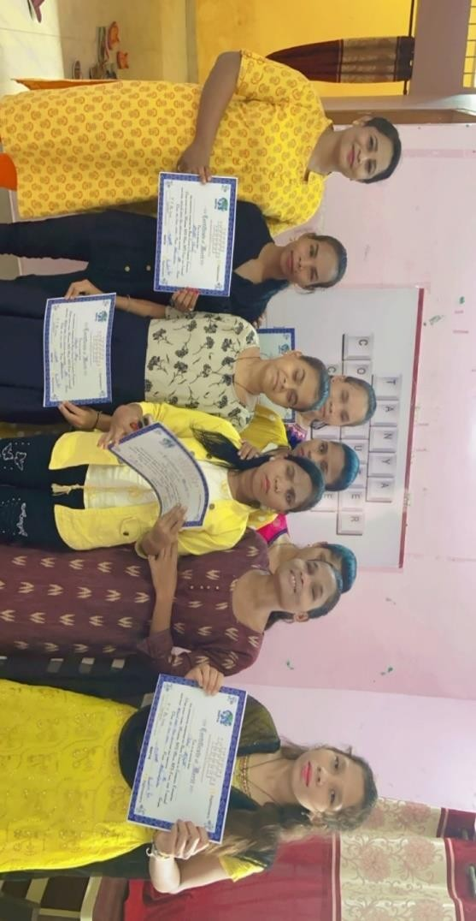

Criteria for selection of students
Initially, we planned to identify visually impaired People being supported by SightSavers in high schools under Inclusive education programme and members of OPD¹ under social Inclusion programme. In the process, students were selected based on the need and their current level of education & computers. It was thought that the girls studying in higher classes would be benefitting post training to get career opportunities. Secondly, preference was given to those who are interested to learn Computer from Red Cross special school, Bhawanipatna, Kalahandi. We developed a format where in basic information of the selected people was collected to understand their background & computer experience.

Workforce
The centre is managed by Sights savers partner DAPTA and monitored by the SightSavers project teams for Social Inclusion and Inclusive Education. A fulltime instructor is available to

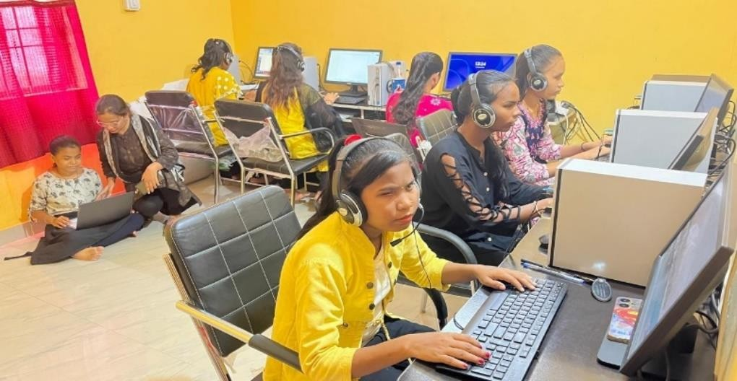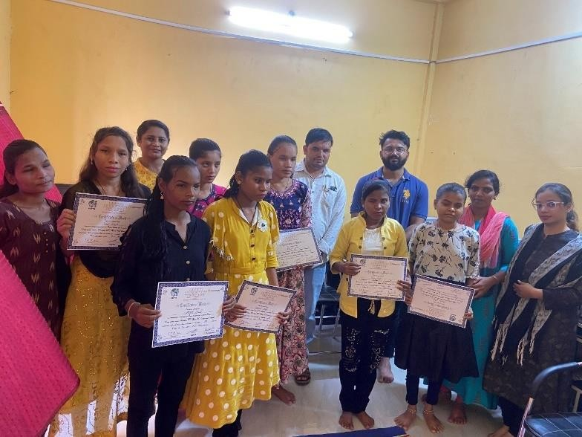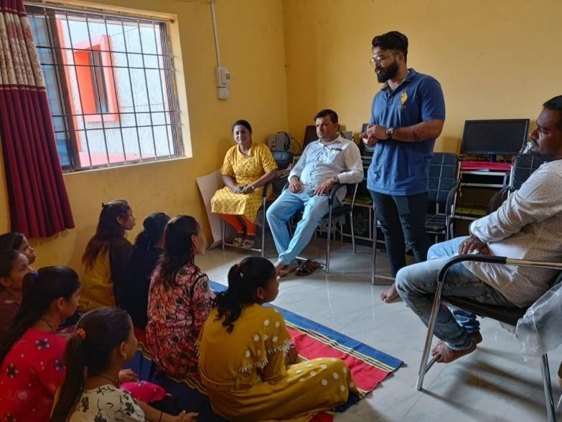
guide the enrolled children through the course. Already 25 numbers of students are graduated
from TCC, Kalahandi.

Progress As
sessment of the Students

Weekly tests for basic and intermediate modules are conducted by the instructor. Two types of
question papers are set for weekly test
-

oral test paper and practical question paper. On
completion of the course, a test for the entir
e course is taken and topic
-
wise marks were given to
the students in weekly/monthly tests.

Details of the Governing Board/Exec. Committee
Sl.  No | Full Time Office Bearer with Address |  | Educational Qualification |  | Professional Qualification | Current  Designation/  Work  Responsibilities |  | Years of  Work  Experiences |  | Area of  Specialization
1. | Mrs. Alaka Nayak |  | M.A |  | Educationalis  t and Social  Worker | President |  | 13 Years |  | Community Mobilization and  Communicatio n
2. | Mrs. Mamata  Mohapatra  Mandar Bagichapada,  Bhawanipatna, Kalahandi. |  | M.A |  | Social Worker | Vice-President |  | 10 |  | Women Empowerment and Social  Development
3. | Mr. Aadarsh Sharma  At- Mandar Bagicha pada  Post- Bhawanipatna  Dist.- Kalahandi |  | B.Tech |  | Social Worker | Secretary cum  Chief  Functionary |  | 3 |  | Community Empowerment  and social  Development
4. | Mrs. Saraswati Mishra  At- Madanmohan Pada  Post- Bhawanipatna  Dist.- Kalahandi |  | B. A |  | Women in  Agriculture, sustainable  Livelihood. | Treasurer |  | 15 |  | Social  Development
5. | Mr. Hrudananda Majhi  At- Lakshmipur  Post- Parmanandapur  Dist.- Kalahandi |  | B. A |  | Social Worker | GB Member |  | 15 |  | Social  Development
6. | Mrs. Belmati Naik  Dumal  Kamthana  Bhawanipatna  Kalahandi |  | Matric |  | Community  mobilization | GB Member |  | 12 |  | Education &  Social  Development
7. | Mr. Parsuram Sabar  Batua  Po Gunduri  Kalahandi, |  | Matric |  | Social Worker | GB Member |  | 12 |  | Social  Development
STAFF DETAILS OF DAPTA
No. of Male Staff |  | No. of Female  Staff |  | No. of TG Staff |  |  | Total No. of Staff |  | No. of Paid Volunteers
82 |  | 38 |  | 05 |  |  | 125 |  | TG-5  Female- 50  Male- 10  Total - 65

TRAINERS ASSOCIATED WITH DAPTA

SL. NO. | NAME | EDUCATION QUALIFICATION | EXPERIENCE IN  DEVELOPMENT SECTOR | SPECIALIZATION
1. | Dipan Kumar Sharma | M.A in sociology. | 19 years in  Development sector | RCH, HIV/AIDS, Micro-plan, livelihood and Disaster management, Malaria Control State level trainer in PRI.
2. | Hrudananda Majhi | B. A | 19 years in  Development sector. | Agriculture, Watershed, Micro plan and Community  Management.Organic farming.
3. | Saraswati Mishra | B. A | 13 years in  Development sector. | Agriculture, SHG, Micro plan, PRA, PRI and GKS, Gender Equity. Organic farming.
4. | Srimukh Pan | B. A | 11 years’ experience in Development sector. | Agriculture, SHG, PRI, Micro plan and GKS.
5. | Khirasindh u Mahalik | M.S. W | 3 years’ experience in  Development sector | HIV/AIDS and Health
6. | Sanjukta Tripathy | M.S. W | 2 years | Women Empowerment, Child  right, PRI
7. | Bitan Kumar Sharma | M.A | 7 years | Women Empowerment,  Livelihood, Education and  Child Right
8. | Somi Singh | M.S. W | 2 years | Women Empowerment,  Education and Child Right
9. | Ajay Kumar Dash | M.S. W | 2 years | Livelihood and Agriculture
10. | Surendra Padhan | M.A | 2 years | Livelihood and Agriculture
12. | Biswanath Harijan | MSW | 6 years’ experience in  Development sector | Health, Education and Livelihood

Legal Entity
Name of the Organization | DEVELOPMENT AGENCY FOR POOR & TRIBAL AWAKENING (DAPTA)
Year of  Establishment  Registration details Act.  Reg. No.-  Date-  Type of organization | 15.08.1989  - Society Registration Act XXX 1860  KLD.469-20-1991  23.01.1990.  NGO – Non-Political, Secular and Nonprofit motive social service organization.  - Registered under Foreign Contribution Act.  Regd. No. -104950021. Dated-17.08.1992 and renewed on dated 01.04.2022  - Registered under Income Tax Act  PAN – AAAAD2331A  TAN – BBND00682D  Regd. No-Judl/10/12A/94-95/19773. Dated- 10.09.1995 and renewed on dated  28.05.2021 bearing number-AAAAD2331AE20214  - Registered under 80G of Income Tax Act  Regd. No- Judl/119/80G/1995-96/15855. Dated-24.10.1995 & renewed on  28.05.2021 bearing number AAAAD2331AF20214  Regd. No-CIT/SBP/Tech./80-G/2011-12/304 Dated, Sambalpur, the 19th April, 2011 and renewed on dated 28.05.2021  Regd under Nitti Aayog- OR/2016/0101255  Regd under CSR 1- CSR 00006456 of dated 22/05/21

We convey our heartfelt gratitude to all friends, well-wishers, donors and resource agencies and above all the community we work with for their kind & benevolent
support and cooperation and travelling with us in the development journey.

Our Bankers |  |  |  |  | Our Auditor
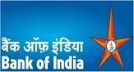  Bank of  India  Palace  Road Bhawanipatna  PIN-766001  Dist.- Kalahandi |   Canara  Bank  Bhawanipatna,  Kalahandi |  |   State Bank  of  India, NDMB Parliament  Street, New Delhi |   C.A. S. Hussain  Mob No. 067262  BHAWANIPATNA,  Kalahandi  ODISHA- 766001

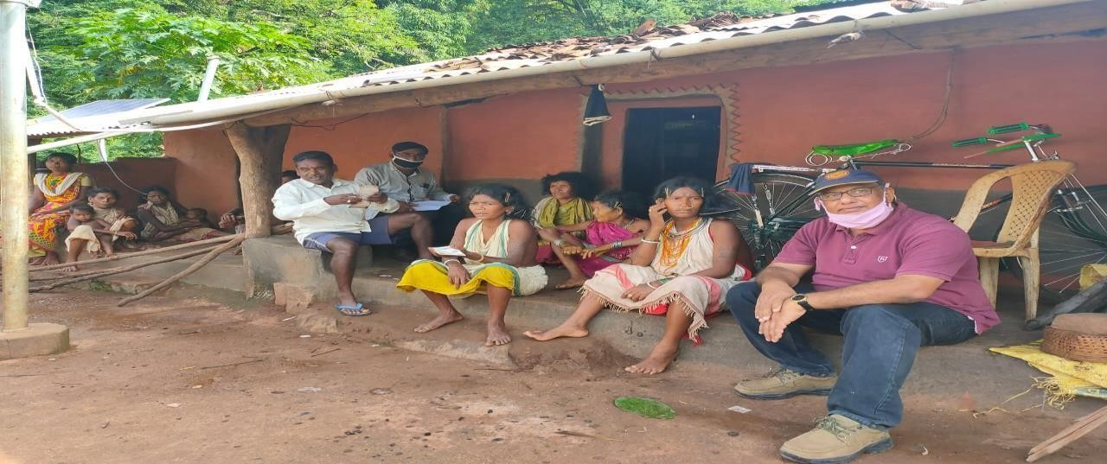

Act of sacrifice, charity and penance
Are not to given/up
They must be performed
Indeed, Sacrifice, Charity and penance Purity the great soul.

Aadarsh Sharma, Secretary, DAPTA

Annual Report-DAPTA 2023-2024

